 

#### VINE TREE PRIMARY SCHOOL

DANE BANK AVENUE

CREWE

CHESHIRE

CW2 8AD

Headteacher

Mr Darren Locke Tel: 01270 661526

e-mail [head@vinetree.cheshire.sch.uk](mailto:head@vinetree.school.cheshire.org.uk) Fax: 01270 650367

or [admin@vinetree.cheshire.sch.uk](mailto:admin@vinetree.cheshire.sch.uk) (office)



Dear Parents

Week beginning 18th September is Jeans for Genes Week and on Friday 22nd September all the classes at Vine Tree School will have the opportunity to be involved in our **Vine Tree Jeans for Genes Day**. The children are asked to bring in £1 so that they may wear their jeans to school instead of their school trousers or skirt. Please note that it is NOT a non-uniform day, all other items of school uniform should be worn.

There are eight partner Jeans for Genes Charities and the money helps to fund vital research into genetic disorders affecting children as well as providing valuable support services for families, for more information go to <https://www.jeansforgenes.org/who-we-are>

Previous year’s Jeans for Genes Day have been a great success and photographs were taken to provide a lasting memory of the day.

Thank you for your support

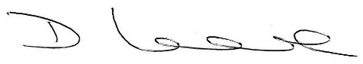

Mr Darren Locke

Headteacher