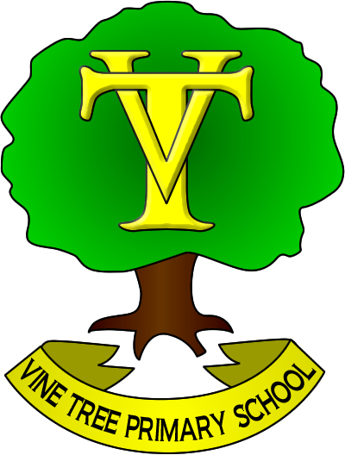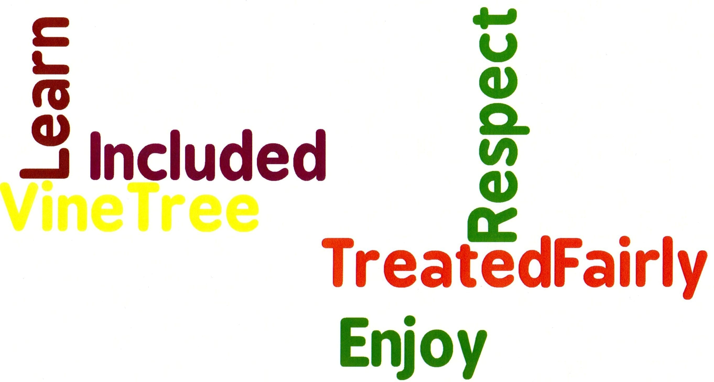

VINE TREE PRIMARY SCHOOL
DANE BANK AVENUE
CREWE
CHESHIRE
CW2 8AD

Headteacher
Mr Darren Locke Tel: 01270 661526
e-mail head@vinetree.cheshire.sch.uk Fax: 01270 650367
or admin@vinetree.cheshire.sch.uk (office)

Thursday 18th June 2020

Dear Parents

You will be aware that, as a part of your child’s educational experience at Vine Tree Primary School, we aim to promote personal wellbeing and development through a comprehensive taught programme of Personal, Social, Health and Economic (PSHE) education that gives children the knowledge, understanding, attitudes and practical skills to live healthy, safe, productive and fulfilled lives, both now and in the future.

The Department for Education has announced changes to relationships and sex education (RSE). These changes will come into effect from September 2020 and all schools will be required to comply with the updated requirements by the Summer term 2021. This means that we’ll be reviewing our RSE curriculum and policy so we can be sure that our RSE provision is appropriate for our pupils based on their:
- Age
- Physical and emotional maturity
- Religious and cultural backgrounds
- Special educational needs and/or disabilities

What does the new guidance mean?
The new guidance focuses on healthy relationships and keeping children safe in the modern world. It also covers a wide range of topics relating to physical and mental health, wellbeing, safeguarding and healthy relationships. Learning about the emotional, social and physical aspects of growing up, will give children and young people the information, skills and positive values to have safe, fulfilling relationships and will help them take responsibility for their own well-being.

As with all statutory subjects, there is no right to withdraw from Relationships Education or Health Education or any content from the Science curriculum. This means that pupils cannot be withdrawn from lessons on the Changing Adolescent Body. Parents have the right to request that their child be withdrawn from some or all of the Sex Education which does not form part of the Science National Curriculum.

How will this be delivered?
This guidance will form part of our school’s PSHE education programme which is taught throughout the school in every year group and is monitored and reviewed regularly.
All teaching in PSHE will take place in a safe learning environment and be underpinned by our school’s vision and values. A variety of opportunities will be provided for pupils to ask questions to further their understanding and to find out more about what affects them personally.

Parent Consultation
It is important that there is an open conversation between parents and school to ensure that the children are given the best PSHE and RSE provision possible. We would like to gain views and opinions from you to inform how the school’s Relationship and Sex Education Curriculum will be taught. We encourage any feedback and suggestions which could be reflected in our policy, as well as any questions that you, as parents, may have about the new guidance or coverage.

To help you understand the curriculum requirements we need to meet, please do take a look at the enclosed summary of what all pupils are expected to know by the end of primary school. I have also attached a summary of the Science National Curriculum, which details which elements of sex education are taught in primary school.

Please access the Google Form https://forms.gle/Xp7ndaqMFJ1PNm7f6 to give us your input on SRE at Vine Tree. Your responses will be used to inform Vine Tree’s new SRE policy which will be shared with you for feedback before its implementation. Please respond by Friday 26th June.

Many thanks

Miss Thomas
PSHE Lead Teacher

