Vine Tree Primary School
Reading overview Year 1 2022-2023
Selection via Voting Stations
Term  link | 2 weeks Fiction | 2 weeks non-fiction |  | 2 weeks poetry | 1week:  No Outsiders
Autumn 1  driver: geography where in the world do people live?  Science: on Safari | Title: The Whale who wanted more  Author: Rachel Bright  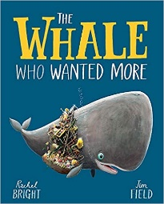  Title: the storm whale in winter  Author: Benji Davies  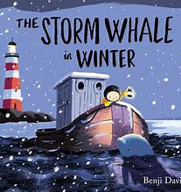  Title: Meerkat Mail  Author: Emily Gravett  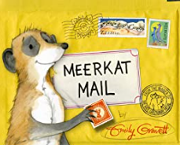  Or  Title: The Ugly Five  Author: Julia Donaldson  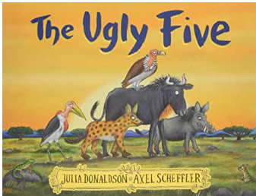 | Title: Big Book of the UK  Author: Imogen Rusell Williams  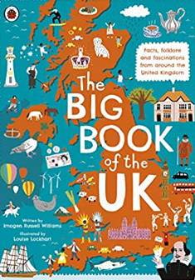  Title: are your stars  like my stars?  Author: Leslie Helakoski  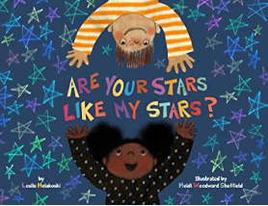  Title: Welcome to our world  Author: Moira Butterfield  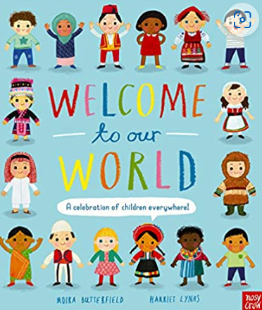  Title: We are together  Author: Britta Teckentrup  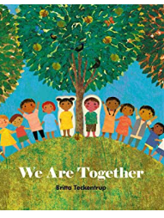  Title:one day in our blue planet in the rainforest  Author: Ella Bailey  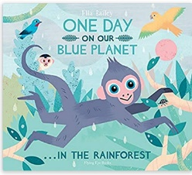  Title: We’re roaming in the rainforest  Author:Laurie Krebs  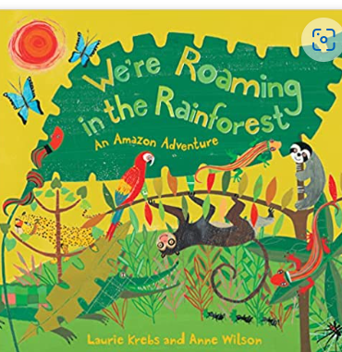  Title: Big Blue Whale  Author: Nicola Davies  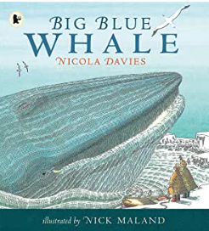 |  | Title: Michael Rosen  Oh Dear!  Title: Splish Splash Splosh  (Zim Zam Zoom anthology)  Title: Greetings  Poet: Leslie Newman (from p84 a world full of poems anthology)  Title: how to love your little corner of the world  Poet: Eileen Spinelli (from a world full of poem p51) | Title: Elmer  Author:  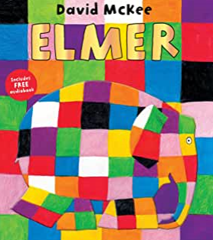  Theme: What is the same  And different about us?
Autumn 2  driver: history – my family history  science - Who am I? | Title: lost in the toy museum  Author:David Lucas  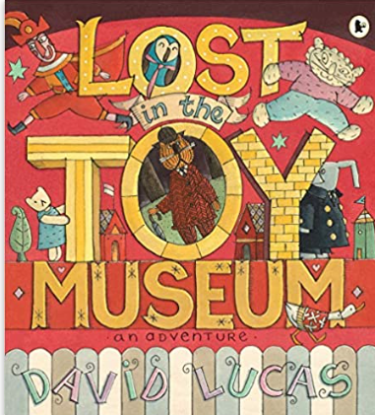  Title: That Rabbit belongs to Emily Brown  Author: Cressida Cowell  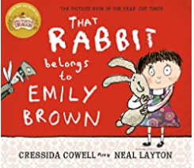  Title: Teddy Robber  Author: Ian Beck  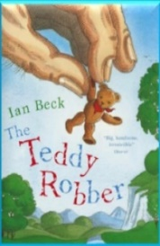  Title: the Queen’s Hat  Author: Steve Anthony  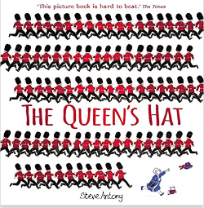  Title: the Missing Piece  Author:Jordan Stephens  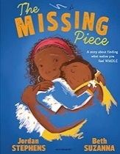 | Title: how to be more Paddintgon  : a book of kindness  Author: Michael Bond  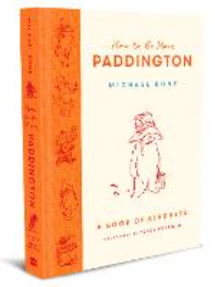  Title: toys galore  Author: Peter Stein  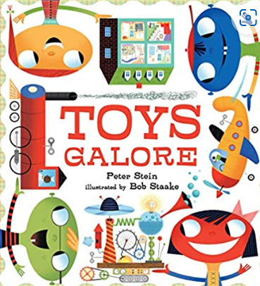  Title: In the past:Toys  Author: Dereen Taylor  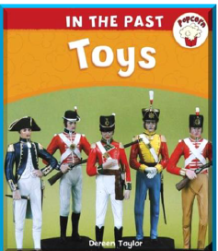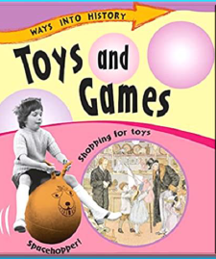  Title: Toys and Games  Author: Sally Hewitt  Title: The Girls  Author: Lauren Ace  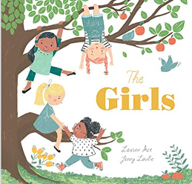  Or:  Title: the body book  Author: Hannah Alice  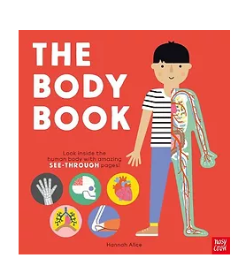  Title: look in side your body  Author: Louie Stowell  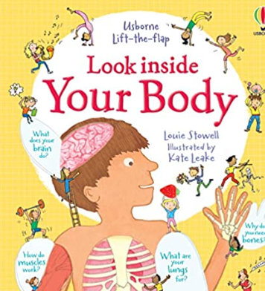 |  | Title: Dream train (I’m a little alien anthology James Carter)  Title: rickety train ride poet: tony mitton (prom p91 a world full of poems athology)  Title: Firework poem  From Zim Zam Zoom anthology  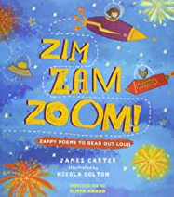  Title: The more it snows (winter poem from Winnie the Pooh)  Poet: A A Milne  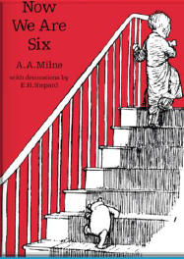  Title: Help wanted!  Poet: Timothy Tocher | Title: My Grandpa is  Amazing  Author: Nick  Butterworth  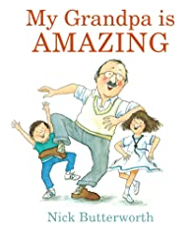  Theme: Who is special  to us?
Spring 1  Author focus: Jeanne Willis  Curriculum driver: history – explorers | Title:Tadpole’s Promise  Author:Jeanne Willis  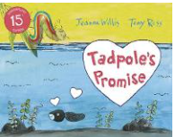  Title: Slug needs a hug  Aurhor: Jeanne Willis  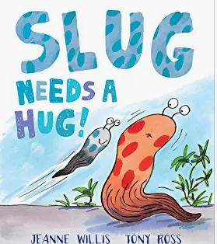  Title: wild child  Author: Jeanne Willis  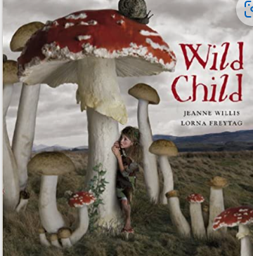  Title: Stardust  Author: Jeanne Willis  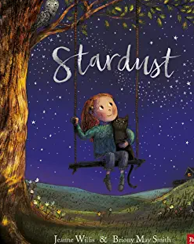  Title: Poles Apart  Author: Jeanne Willis  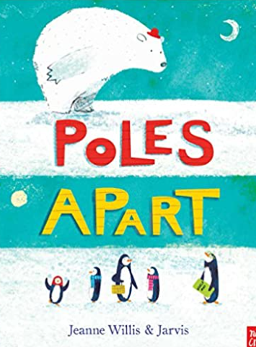  Title: mayfly day  Author: Jeanne Willis  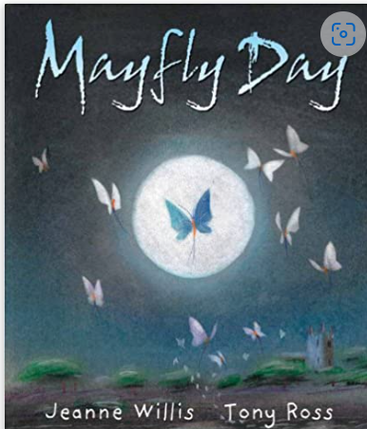 | Literacy Shed: Explorer’s kit/Famous Explorers  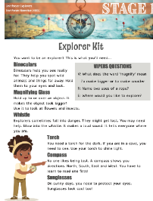  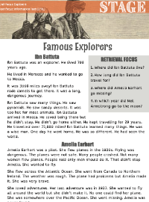  Title: do you love exploring?  Author: Matt Robertson  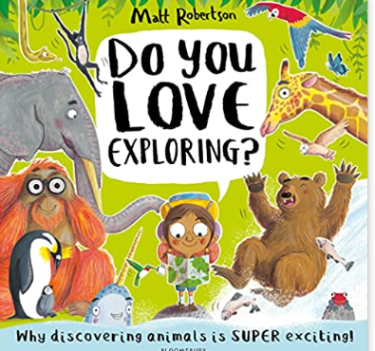  Title: my little book of big questions  Author: Britta Teckentrup  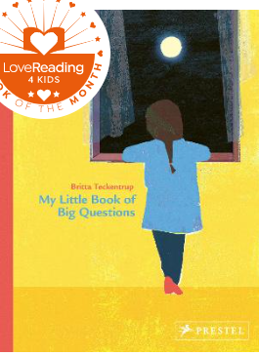 |  | Title: the explorer  Author: Literacy Shed  Title: The Brush Baby  Poet: Roger Mcgough  (Poetry Pie anthology)  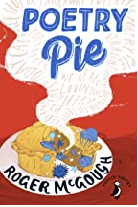  Title: What are little girls made of?  Author: Jeanne Willis  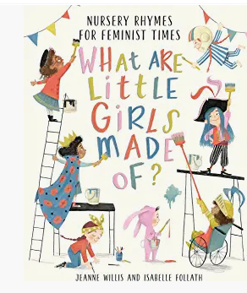  Title: Billy Mcool  Poet: Aoife Mannix  https://clpe.org.uk/videos/video/aoife-mannix-billy-mccool  visualisation – can you draw Billy Mcool/The Brush Baby? | Title: Max the Champion  Author: Sean Stockdale,  Alexandra Strick and  Ros Asquith  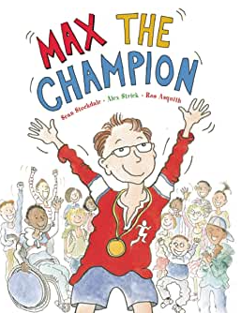  Theme: What helps us  stay healthy?
Spring 2  Driver: geography – What’s it like where we live?  Art: Colour splash linked to picture books (end column) | Title: The Little Gardener  Author:Emily Hughes  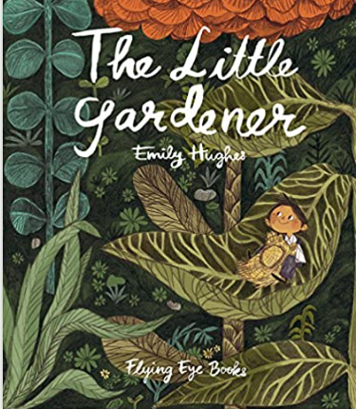  Title: The Rabbit Problem  Author: Emily Gravett  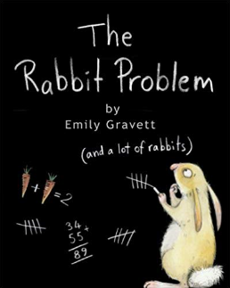  Title: The Velveteen Rabbit (opening extract)  Author: Marjery Williams  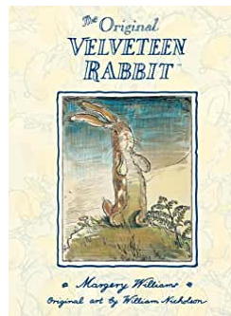  Title: Wanted: Ralfy Rabbit, Book Burglar  Author: Emily Mackenzie  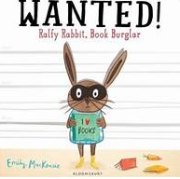  Title: Rabbit Rabbit Rabbit  Author: Lorna Scobie  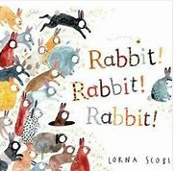 | Title: A little guide to gardening  Author:Dr Jo Elworthy  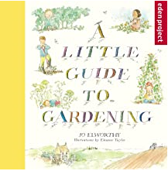  Title: how to help a hedgehog and protect a polar bear  Author: Jess French  Extracts from p8-11  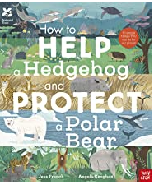  Title: A little guide to wild flowers  Author: Charlotte Voake  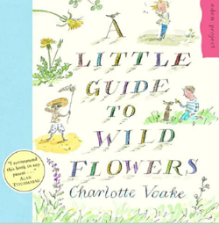  Title: We build our homes  Author: Laura Knowles  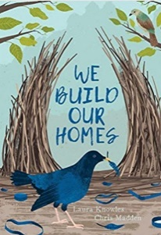  Title: Big book of birds  Author: Zuval Zommer  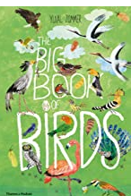  Title: The Big Book of Blooms  Author:Yuval Zommer  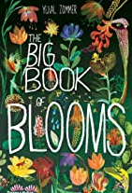  Title: we are going on a bear hunt: my adventure field guide  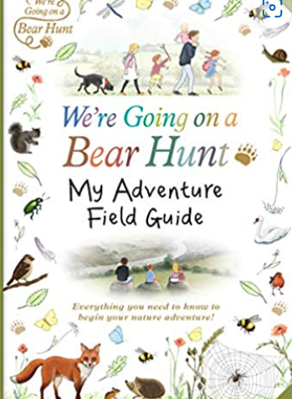  Title: do you love bugs?/Bug Hotel  Author:Matt Robertson/Libby Walden  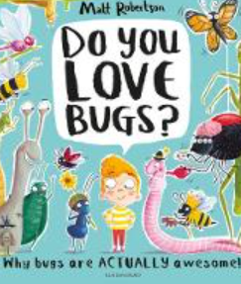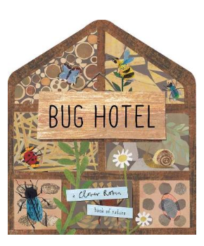 |  | Title: What do you do on a nature walk?  Poet: Kate Williams  Title: The Rabbit Habit  Poet: Liana Mahoney  Title:Nature’s Numbers  Poet: John Cotton  Title: We have a little garden  Poet: Beatrix Potter  Title: What is it? Rabbit riddle  Title:Little Peter Rabbit nursery rhyme  Title: pond poem from ‘I’m a little alien anthology (p53)  Poet: James Carter | Title: Rabbityness  Author: Jo Empson  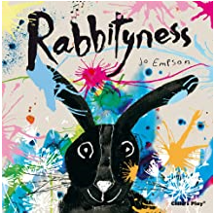  Title: Dadajis Paintbrush  Author: Rashmi  Sirdeshpande  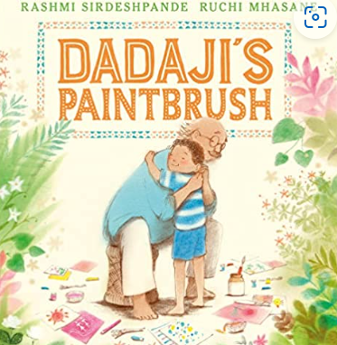
Summer 1  Curriculum driver:  Science: arctic wolves  Author focus: Mini Grey  (the adventures of the dish and spoon, traction man, toys in space) | Title: Good Little Wolf  Author: Nadia Shireen  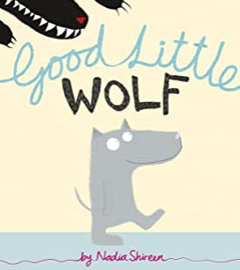  Title: The last wolf  Author: Mini Grey  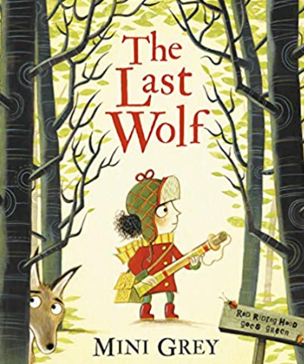  Title: You’re snug with me  Author: Chitra Soundar  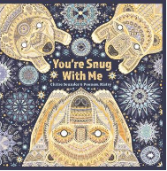 | Title: Wolfie’s Secret  Author: Nicola Senior  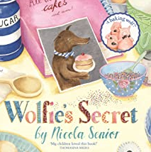  Title: The Way Home for Wolf  Poet:Rachel Bright  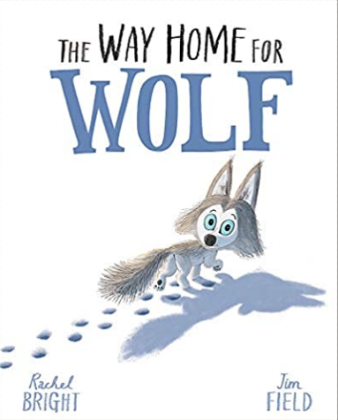  Title: Can we really help polar bears?Yes we can!  Author:Katie Daynes  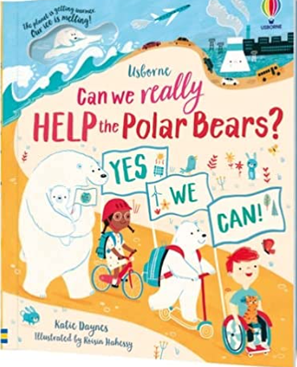 |  | Title: Yumtime!  From Zim Zam Zoom  Title Have you met A WOLF?  From Zim Zam Zoom  Title: At the Zoo  William Makepeace Thackey  Title: Animal Talk  Charles Ghigna | Title: Ten Little Pirate  Author: Mike Brownlow  and Simon Rickerty  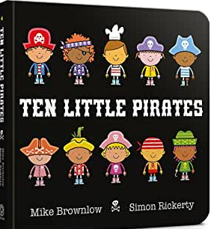  Who helps us to keep  safe?
Summer  2  Curriculum driver: science: holidays  geography: where do our favourite animals live? | Title: The Lighthouse Keeper’s Lunch  Author: Ronda Armitage  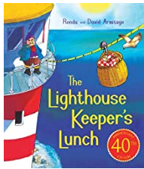  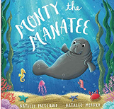  Title: Dear Earth  Author: Isabel Otter  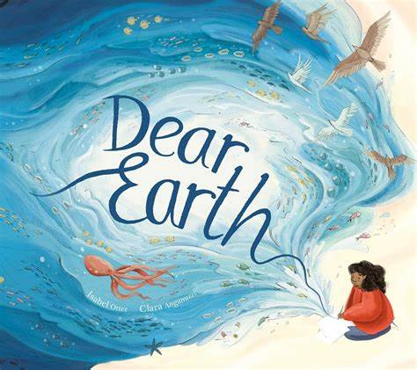 |  | Title: how to help a hedgehog and protect a polar bear  Author: Jess French  P38/39 coastal species/ocean species  Title: save the sea  Author: Sarah Levete  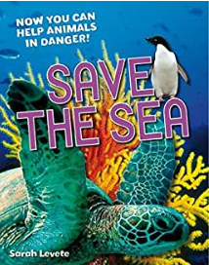  Title: looking after the ocean  Author: Jay Dale  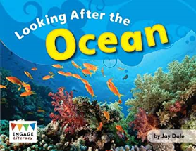 | Seaside poems:  Title: advice to a lolly licker  Poet: Pie Corbett  Title: over my toes  Poet: Michael Rosen  Title: Sunset and custard  Poet: Roger Mcgough  Title: do you C what I C?  Poet: Kenn Nesbitt  https://www.poetry4kids.com/poems/do-you-c-what-i-c/  title: little by little fish (from I’m a little alien anthology p38)  poet: James Carter | Title: My World, Your  World  Author: Melanie Walsh  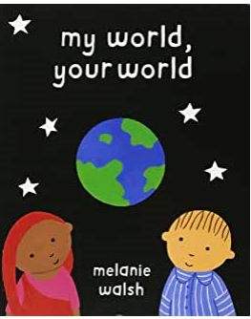  How can we look after  Each other and the  World?

