Vine Tree Primary School
English overview Year 3 2022-2023
Term  C driver | 2 weeks Fiction | 2 weeks non-fiction | 1-2 weeks poetry | 1 -2 week RSE/PSHE
Autumn 1  Curriculum driver:  Science: am I attractive enough? | Title: The Robot and the Bluebird  Author: David Lucas  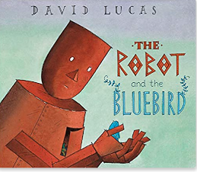  Title: The wild Robot  Author: Peter Brown  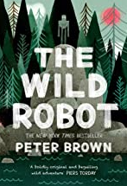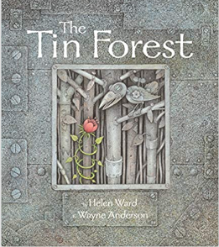  Title: The Tin Forest  Author: Helen Ward  Content domain: 2a vocabulary | Title: Forces and Magnets  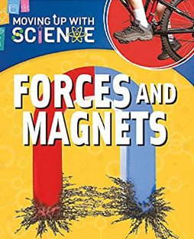  Title: Forces in Action  Author: Peter Riley  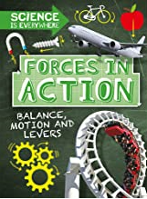  Title: Robots  Author: Melissa Stewart  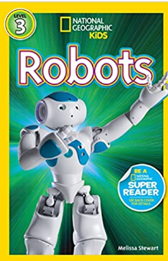  Content domain: 2c summarising | Title: The coming of the Iron Man  Poet: Brenda Williams  Title: Opposites Attract  Poet:  Title: Frost  Poet: Valerie Bloom (p1 hot like fire anthology- great for inference)  Content domain: 2d – Inferring/analyse | Title:Beegu  Author: Alexis Deacon  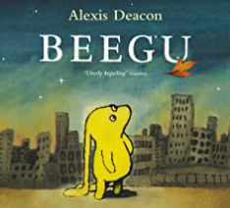  Theme: to be welcoming  How can we be a good  friend?  Content domain:  Visualisation/mixed
Autumn 2  Curriculum driver: science light and shadows  history - bronze and iron age  Author focus: Carol Ann Duffy | Title: The Black Rabbit  Author: Philippa Leathers  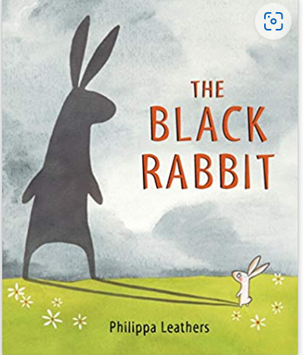  Title: The Tear Thief  Author: Carol Ann Duffy  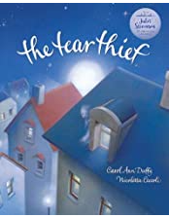  Title: The Magic Thief (opening extract for setting)  Author: Sarah Prineas  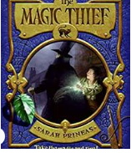  Title: the king who banned the dark  Author: Emily Haworth- Booth  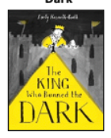  Title: the Dark  Author: Lemony Snicket  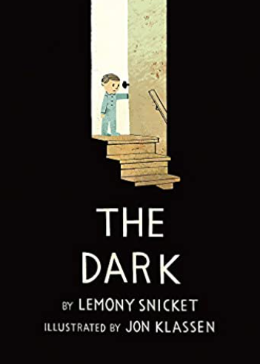  Content domain: 2e predicting  Content domain: 2f explaining language | Title: Little Glow  Author: Katie Sahota  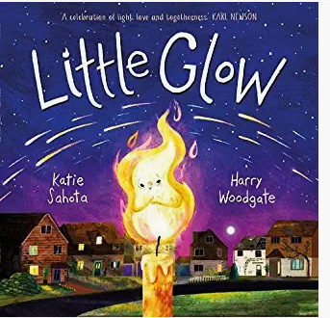  Title: We are the lights that dance in the night  Author: Yuval Zommer  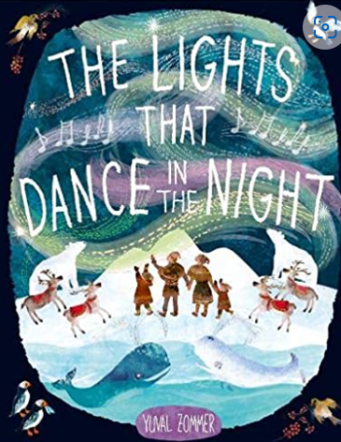  Title: On a beam of light  Author: Nicola Berne  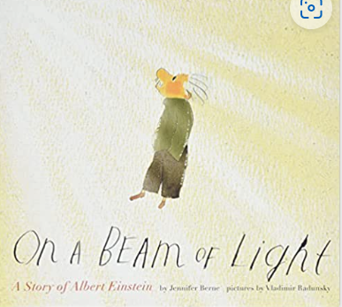  Title:A day in the life  Author:Mike Barfield  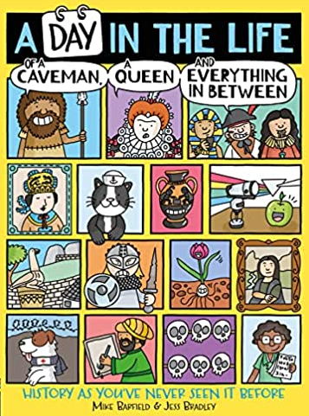  Title: Bronze Age: Knowes of Trotty  Author: Michael Rosen  The Knowes of Trotty | Bronze Age | Grave Goods | POEM | Kids' Poems and Stories With Michael Rosen - YouTube  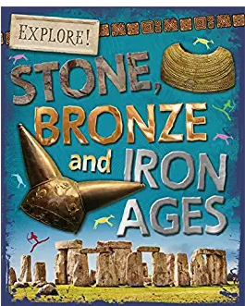  Title: Stone,bronze and iron ages  Author: Sonia Newland  Title: 24 hours in the stone age  Author:Lan Cook  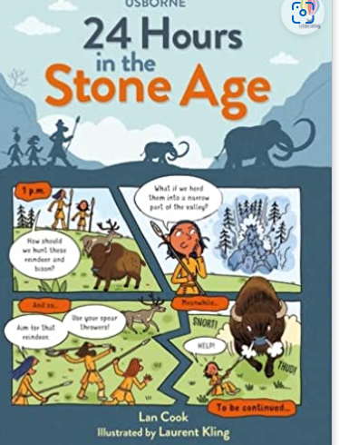  Content domain: 2b retrieval | Title: fire, burn and cauldro bubble magical poems  Poet: Paul Cookson  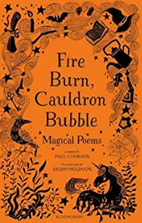  Title: Song of the Witches  Author: William Shakespeare  Title: Witch Ghost  Poet: John lyons  title: Rapunzel  poet: Sue Cowling (shape poem p416 the works 2)  Content domain: 2f explaining language | Title: Oliver  Author:Birgitta Sif  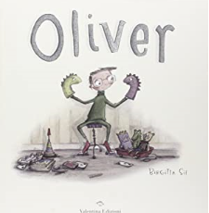  Title: Same same but  different  author: Jenny  Kostecki-Shaw  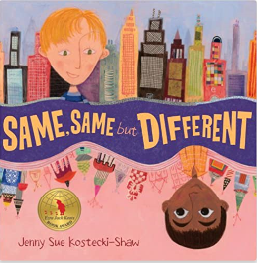  Theme: differences
Spring 1  Curriculum driver: history - Stone Age  Or  Science: food and our bodies | Title: Stig of the Dump  Author: Clive King  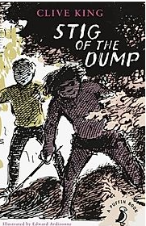  Title: Tek the modern cave boy  Author: Patrick Mcdonnell  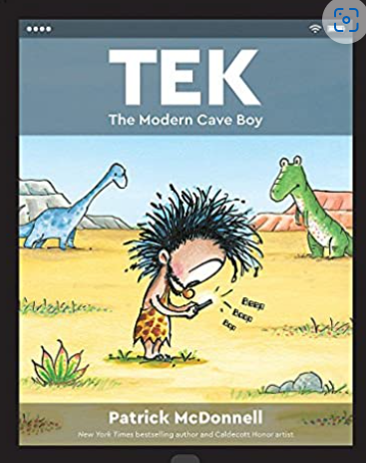  Title: The Wild Way Home  Author: Sophie Kirtley  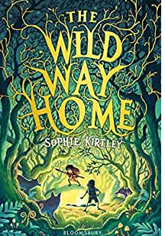  Or  Content domain: 2d – inferring | Title: The Secrets of Stonehenge  Author: Mick Manning  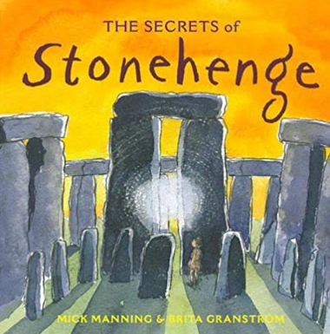  Title: Stone Age  Content domain: summarising  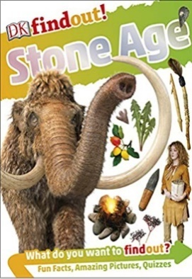  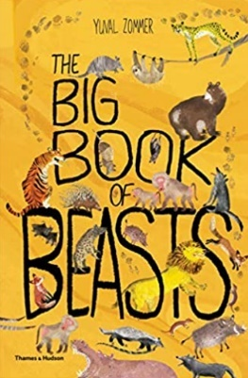  Author: Klint Janulis  Title: the big book of beasts  Author: Yuval Zommer  Title: prehistoric: actualsize  Author:  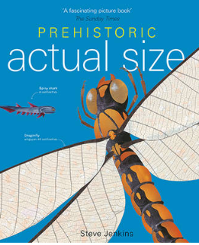  title: Bones  Author: Steve Jenkins  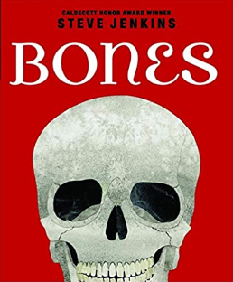  Title: Look Inside your Body  Author: Louis Stowell  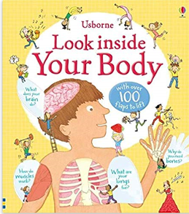  Title: life on earth: Human body  Author:heather Alexander  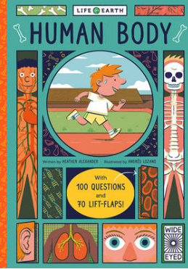  Content domain: 2a vocabulary | Title: Woolly Mammoth  Poet: James Carter  Title: I was born in the Stone Age  Poet: Michael Rosen  Content domain: 2a vocabulary | Title: Two Monsters  Author: David Mckee  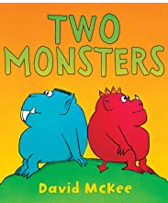  Theme: solving a problem
Spring 2  Curriculum driver: science plants | Title: The Night Gardener  Author: Terry Fan and Eric Fan  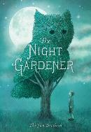  Title: the owl who was afraid of the dark  Author: Jill Tomlinson  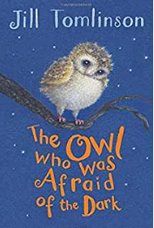  Content domain: 2e  Predicting  Content domain:  2g authorial intent | Title: The Wonders of Nature  Author: Ben Hoare  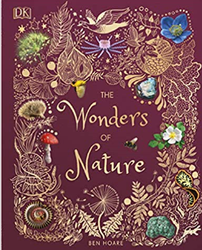  Title: Trees, leaves, flowers & seeds  Author: DK  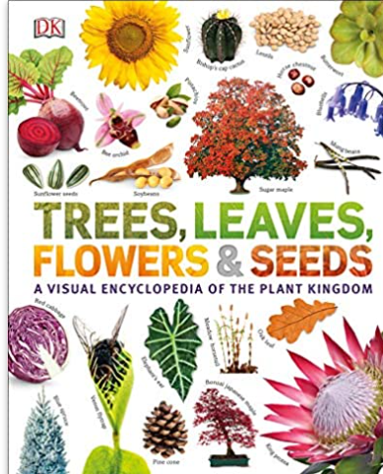  Title: who makes a forest?  Author: Sally Nicholls  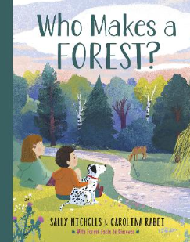  Content domain: 2b retrieval | Title: how to help a little corner of your world  Poet: Eileen Spinelli  Title: I am the seed that grew the tree  Author: Fiona Waters  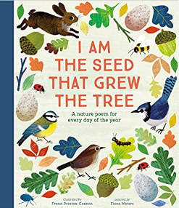  Title: the owl and the pussycat  Poet: Edward Lear  Content domain: 2b retrieval | Title: This is our House  Author: Michael Rosen  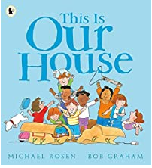  Theme: discrimination  Content domain:  2g authorial intent
Summer 1  Curriculum driver: history -Ancient Greece | Title: Firework Marker’s Daughter  Author: Phillip Pullman  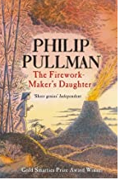  Title: Greek Myths  Author: Geraldine McCaughrean & Emma Chichester Clark  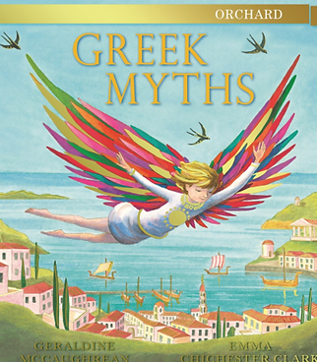  Title: The Fox and The Star  Author: Coralie Bickford-Smith  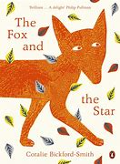  Content domain: 2h compare/analyse  2e inference | Title: So you think you’ve got it bad?  Author: Chae Straithie  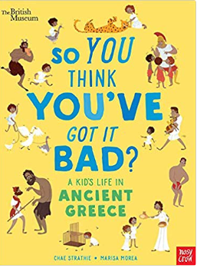  Title: A Visitor’s Guide to Ancient Greece  Author: Lesley Sims  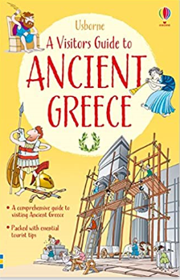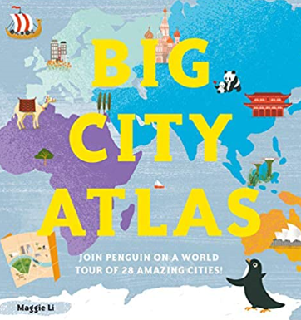  Or  Content domain: 2g authorial intent | Tongue Twisters  Poet: Joseph Coelho  Tricky tongue twisters  Joseph Rosenbloom  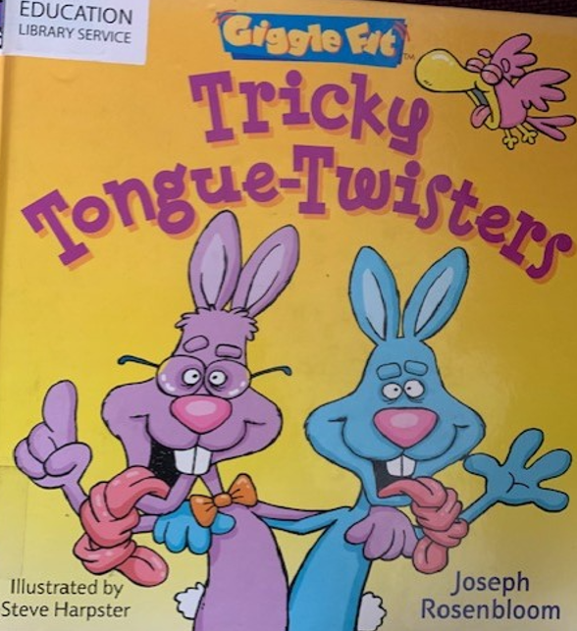  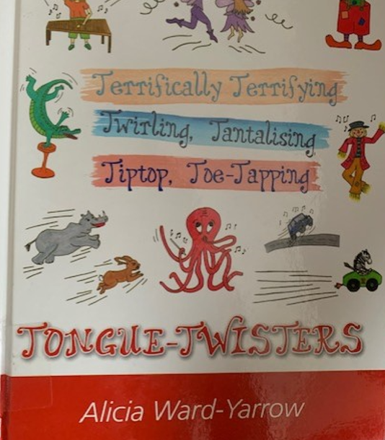  Title: when I’m angry (kenning poem)  Poet: brenda Williams (from a world full of poems p42) | Title: The Huey’s in the  new Jumper  Author: Oliver Jeffers  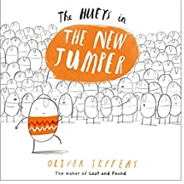  Theme: helping someone  Who Feels different
Summer 2  Curriculum  Driver:  What do rocks tell us about how the earth was formed?  Author focus: Eric Fan | Title: it fell from the sky  Author: Eric Fan  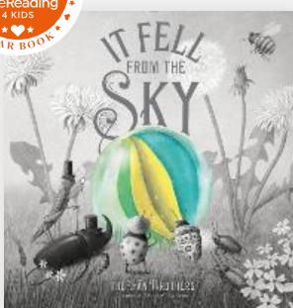  Title: the Barnabus Project  Author: Eric Fan  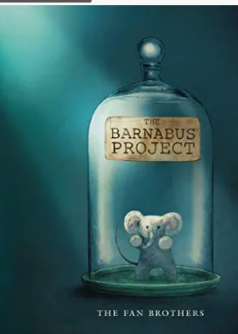  Title: The antlered Ship  Author: Eric Fan  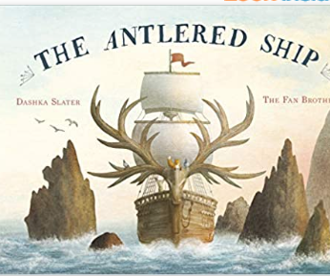  Title: Stone Girl Bone Girl  Author:  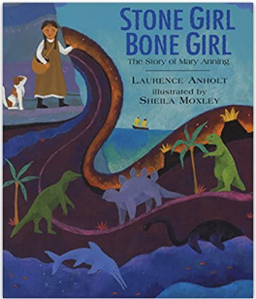  Content domain:2b retrieval | Title: There’s a pebble in my pocket  Author: Meredith Hooper  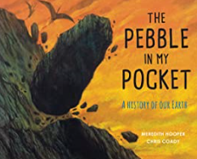  Title: how to help a hedgehog and protect a polar bear  Author: Jess French  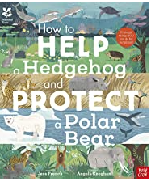  Title: my book of Rocks and Minerals/A Rock is Lively  Author: Dr Devine Denny  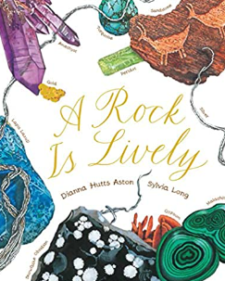  content domain: 2a vocabulary  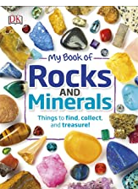 | Title: Music…  Poet: Ann Bonner  Title: don’t be scared  Poet: Carol Ann Duffy (from a world full of poems p45)  Content domain: 2d infer | Title: Perfect  Author: Nicola Davies  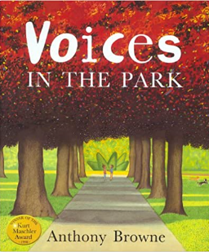  Theme: alienation  Title: Amy Wu and the  Perfect bao  