Year 4 whole class reading overview
2022-2023
Term  & link | 2 weeks Fiction | 2 weeks non-fiction | 1-2 weeks poetry | No Outsiders
Autumn 1  Curriculum driver: Geography  Rivers and the water cycle | Title: A River  Author: Marc Martin  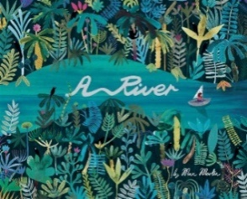  Title: The River Singers  Author:Tom Moorhouse  Modern version of a classic  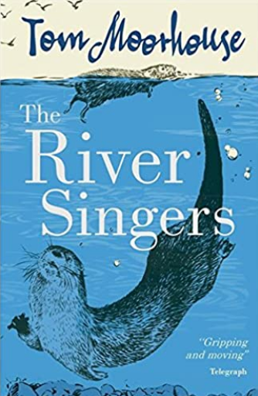  Title: The Wind in the Willows  Author: Kenneth Grahame  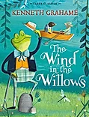  Reading domain: 2a Vocabulary | Title:  Author: Unknown Adventurer  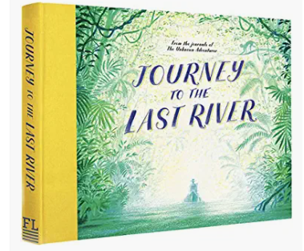  Title: Amazing rivers  Author: JulieVosburgh  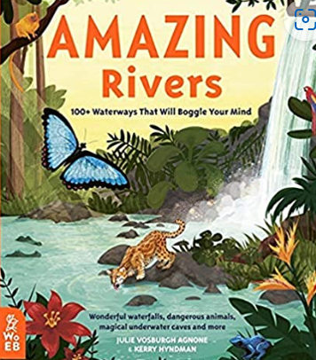  Title: A drop in the Ocean: The story of Water  Author: Jacqui Bailey  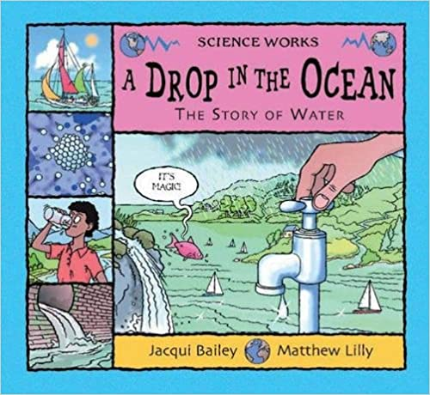  Title: The solid truth about States of Matter with Max Axiom, Super Scientist  Author: Agnieszka Biskup  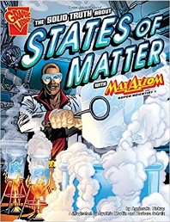  Content domain: 2b retrieval | Title: the river  Poet: Valerie Bloom  Title: A tree toad loved a she-toad  Poet: Anon  (The Works KS2 p80)  Title: The Storm  Poet: Sara Coleridge  (The Works KS2 p125)  Title: Daughter of the sea  Poet: Phillip Gross  Title: Snow & Snow  Poet: Ted Hughes  Title: What’s the matter?  Poet: Tom McGowan  Title: A River’s Journey  Poet: Angela Yardy  Title:Some other names for rain  Poet: Kate Wakeling  Some Other Names for Rain | Centre for Literacy in Primary Education (clpe.org.uk)  Reading domain: 2d Inference | What strengths, skills and interests do we have?  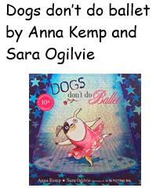
Autumn 2  Curriculum driver: Geography- North America  Science – teeth and eating  Author focus – Joseph Coelho | Title: Our Tower/Overheard in a tower block  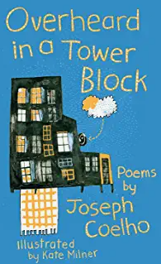  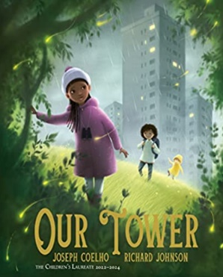  Author: Joseph Coelho  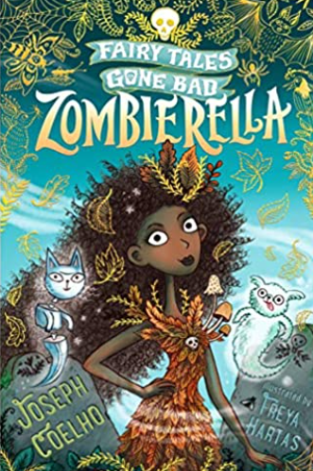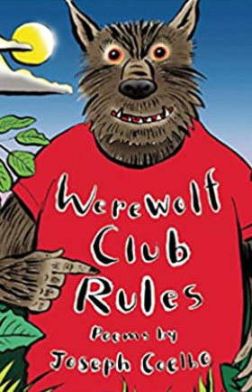  Title: A walk in New York  Author: Salvaatore Rubbino  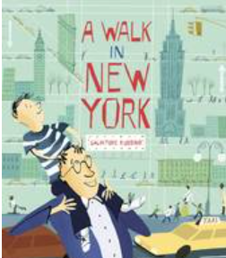  Content domain: 2f explaining language and 2b predicting | Title: city Atlas  Author: Georigia Cherry  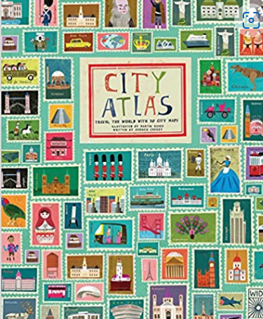  Title: 50 adventures in 50 states/national parks of the USA  Author:Kate Siber  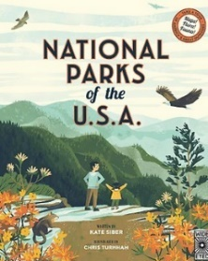  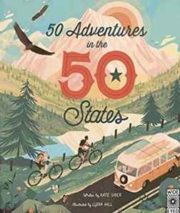  Title: pop up New York  Author: Lonely Planet  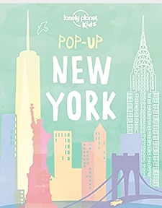  Or  Title: history of the world in 25 cities (New York)  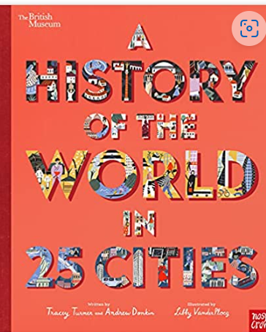  title: How was that built  author:Roma Agrawal  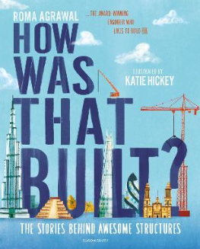  Title: human body Odyssey  Author: Dominic Walliman  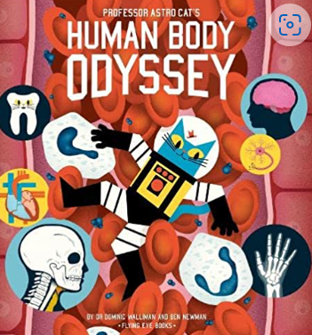  Title: Illumanatonomy  Author: Kate Davies  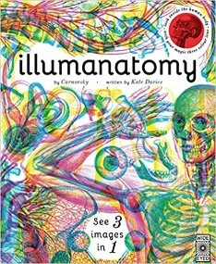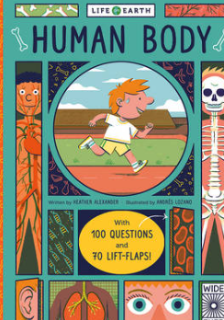  Title:human body  Author: heather Alexander  Title: stuff you should know about the human body  Author:John Farndon  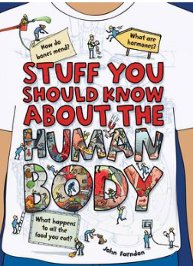  Content domain: 2b retrieval | Title: city lights:  Poet: Lee Bennet Hopkins (from a world full of poems p86)  Title: skyscrapers  Poet: Rachel Field (from a world full of poems p89)  Title: city rain  Poet: Rachel Field (from a world full of poems p85)  Title: star turn  Poet: Francis Nagle  (the Works 2 p218- tour of the human body)  Content domain: explaining language | 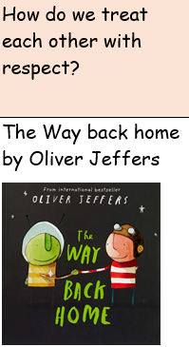
Spring 1  Curriculum driver: History  Why were the Romans so powerful?  Author focus: Chris Riddell | 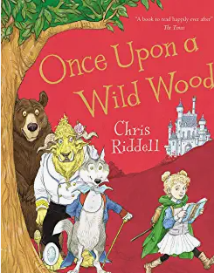  Author focus: Chris Riddel  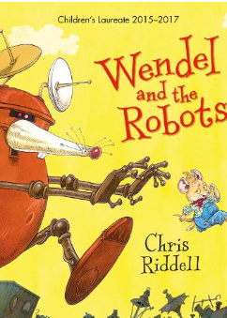  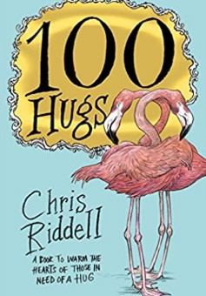  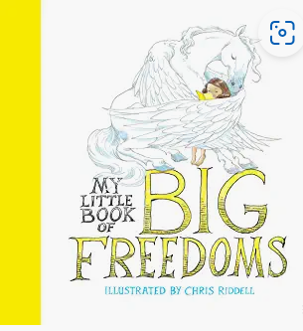  Reading domain: 2d Inference | Title: What the Romans did for us  Author: Alison Hawes  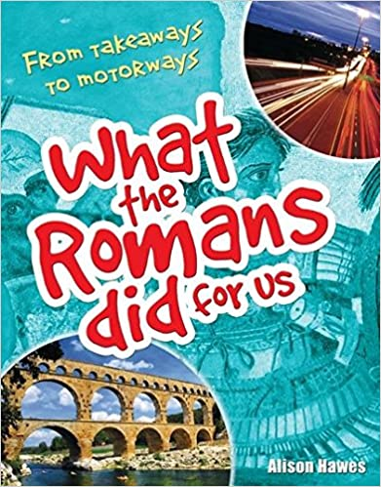  Title: Life in a Roman Villa  Author: Jane Shuter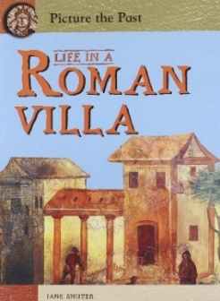  Title: Avoid being a Roman Soldier  Author: David Stewart  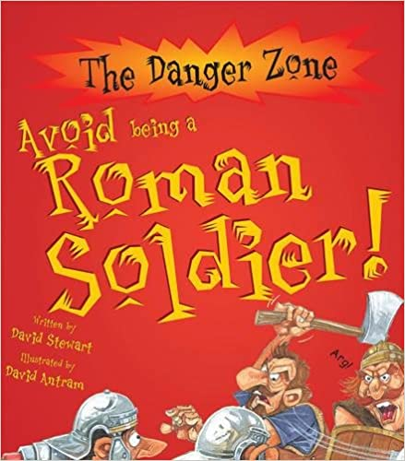  Reading domain: 2a Vocabulary/2c Summarising | Title: Romulus and Remus  Poet: Rudyard Kipling  Title: Roman  Poet: Hervey Allen  https://www.poetryfoundation.org/poetrymagazine/browse?contentId=16713  Title: The Romans in Britain  Poet: Judith Nicholls  https://childrens.poetryarchive.org/poem/the-romans-in-britain/  Title: Roman Invasions  Celia Warren  (The Works 72)  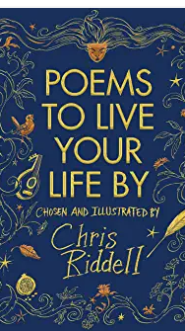  Reading domain: 2c Summarising/ Paraphrasing | 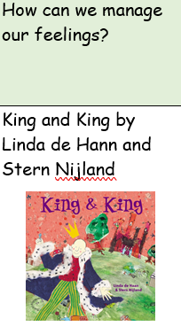
Spring 2  Curriculum driver: Science  Living things | Title: Whales: an illustrated celebration  Author: Ian Kelsey  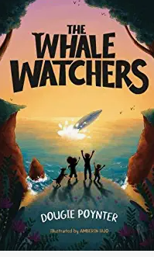  Title: Dear Greenpeace  Author: Simon James  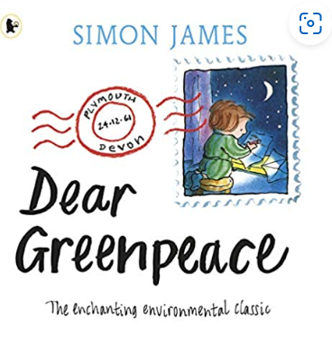  Title: the lost whale  Author: Hannah Gold  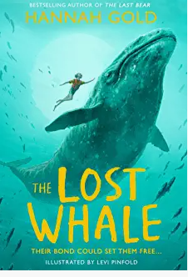  Reading domain: 2e Prediction  And 2g authorial intent | Title: The World of Whales  Author: Darcy Dobell  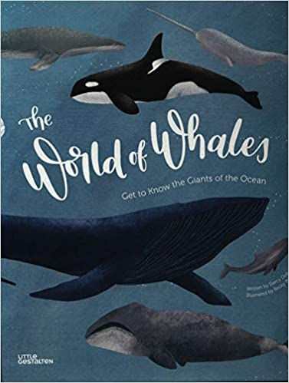  Title: Big blue whale  Author: Nicola Davies  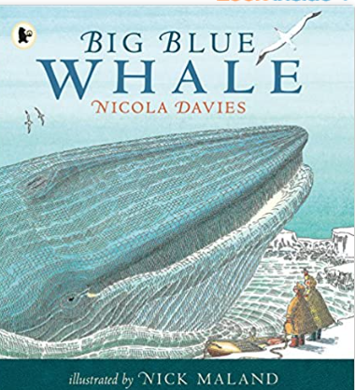  Reading domain: 2b Retrieval | Title: Whale Music  Poet: Tony Bradman (from wild and wonderful poems about the natural world)  Title: leave the whales alone please  Poet: Tony Bradman  Poet: If you Ever  Poet: Anon (from all the wild wonders)  Reading domain: 2g authorial intent | 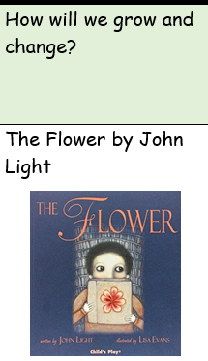
Summer 1  Curriculum driver: History  How can we rediscover the winders of Ancient Egypt?  Science – sound | Title: Secrets of a Sun King  Author: Emma Carroll  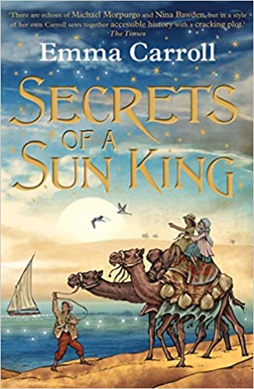  Title: The Scarab’s Secret  Author: Nick Would and Christina Balit  Title: Myth Raiders: Claw of the Sphinx  Author: A J Hunter  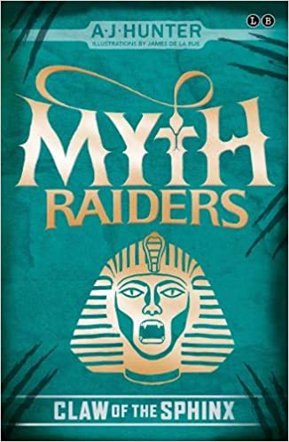  Reading domain: 2g Authorial intent | Title: Pharoah’s fate: Solve the Ancient Egyptian Mystery  Author: Camille Gautier  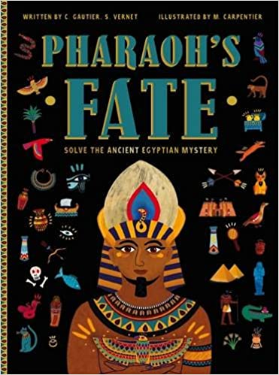  Title: Egyptomania  Author: Emma Guiliani 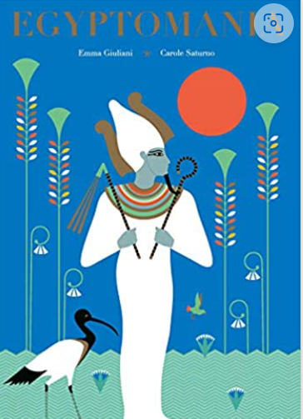  Title: Egyptology: Search for the tomb of Osiris  Author: Emily Sands  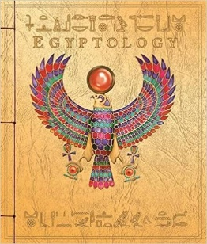  Title: Egypt Magnified  Author: David Long  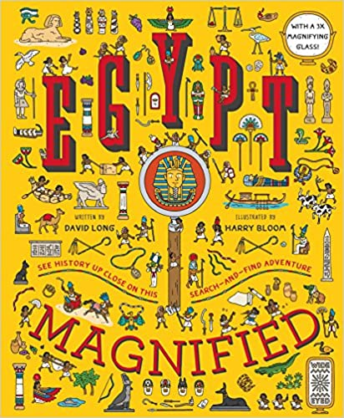  Reading domain: 2h Comparing | Title: Melvin the Mummy  Poet: Kenn Nesbitt  https://www.poetry4kids.com/poems/melvin-the-mummy/  Title: The Sound Collector  Poet: Roger McGough  Title: A poem to be spoken silently  Poet: Pie Corbett  Title: This might not sound serious  Poet: Joan Poulson  https://childrens.poetryarchive.org/poem/this-might-not-sound-serious/  Title: Song for a spent 100W bulb  Poet: Jacob Sam-La Rose  https://childrens.poetryarchive.org/poem/song-for-a-spent-100w-bulb/  Reading domain: 2d Inference/ 2h Comparing | 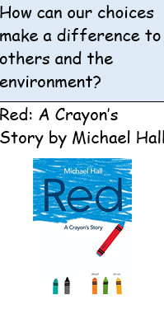
Summer 2  Curriculum driver: PSHE  How can we manage risk in different places? | Title: here I am  Author: Patti Kim  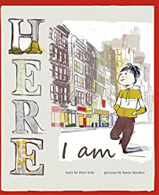  Title: Leaf  Author: Sandra Dieckmann  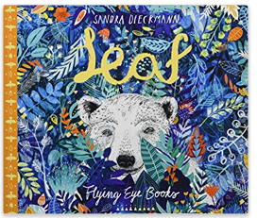  Title: running on the roof of the world  Author: jess Butterworth  (chapter 1: rules)  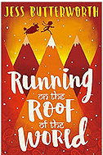  Reading domain: 2d Inference | Title: Who are refugees and migrants? What makes people leave their homes? And other big questions  Author: Michael Rosen  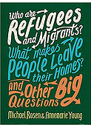  Title: The Book of Big Science Ideas  Author: Freya Hardy  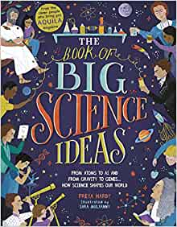  Reading domain: 2b Retrieval  Reading domain: 2a Vocabulary | Title: refugees  Poet: Brian Billston  Title: reward and punishment  Poet: Roger McGough  Title: a poison tree  Poet: William Blake | How can we manage risk in different places?  Title: The Journey  Author: Francesca Sanna  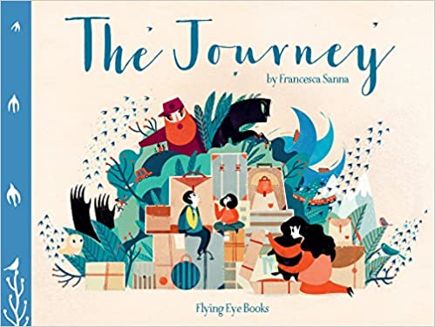  Title: The Silence Seeker  Author: Ben Morley and Carl Pearce  