Bingo Books is a collection of high-quality literature for you to share and explore with your child. Similar to the game ‘bingo’, the aim is to get a full house before leaving Year 4! Children will choose a new Bingo Book whenever they finish as some texts are longer than others. We do ask that you treasure these books as they are on loan from our Education Library Service. Please enjoy them and return in a good condition. If books are not returned (or are returned in a poor condition), I’m afraid we will have to ask for a contribution toward a replacement. Enjoy immersing yourself in some wonderful texts. I wonder which will be your favourite!
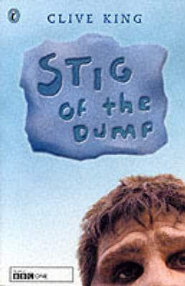  Stig of the Dump  Clive King | 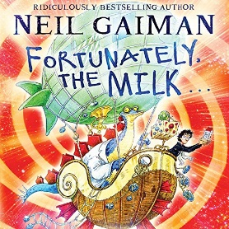  Fortunately the Milk  Neil Gaiman | 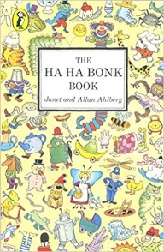  The Ha Ha Bonk Book  Janet and Allan Ahlberg | 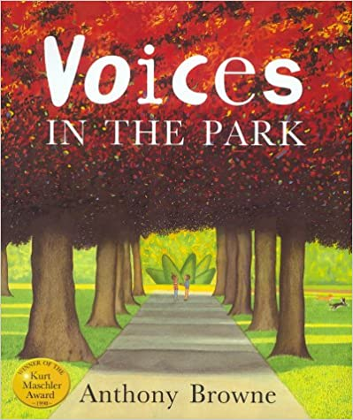  Voices in the Park  Anthony Browne | 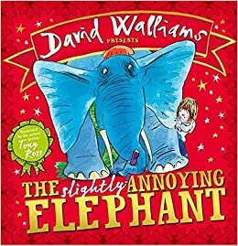  The slightly Annoying Elephant  David Walliams | 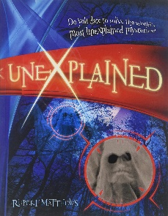  Unexplained  Rupert Matthews | 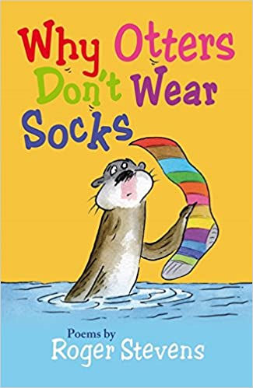  Why Otters Don’t Wear Socks  Roger Stevens | 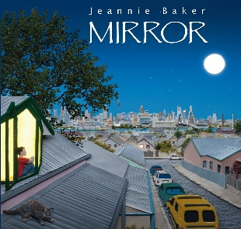  Mirror  Jeannie Baker
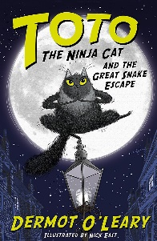  Toto the Ninja Cat and the Great Snake Escape  Dermot O’Leary | 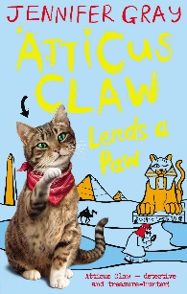  Atticus Claw Lends a Paw  Jennifer Gray | 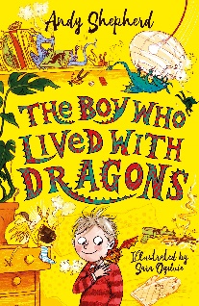  The Boy who Lived with Dragons  Andy Shepherd | 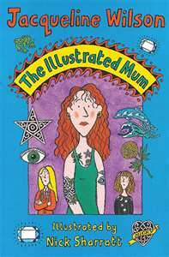  The illustrated Mum  Jacqueline Wilson | 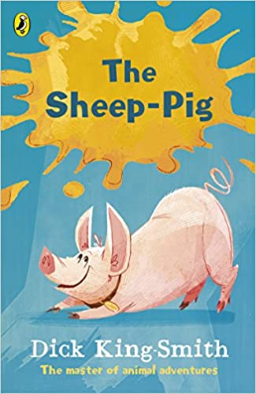  The Sheep-Pig  Dick King Smith | 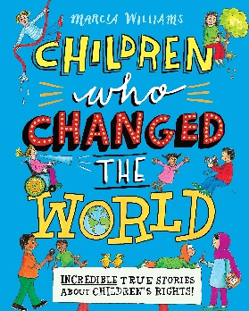  Children who Changed the World  Marcia Williams | 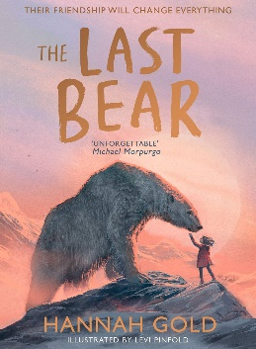  The Last Bear  Hannah Gold | 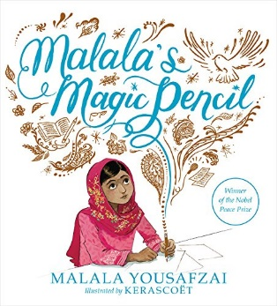  Malala’s Magic Pencil  Malala Yousafzai
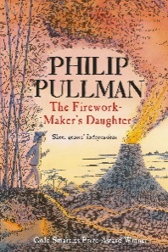  The Firework-Maker’s Daughter  Philip Pullman | 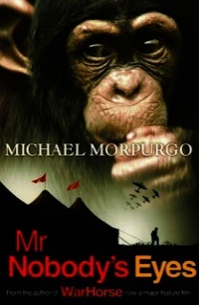  Mr Nobody’s Eyes  Michael Morpurgo | 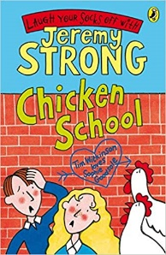  Chicken School  Jeremy Strong | 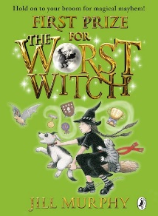  The Worst Witch  Jill Murphy | 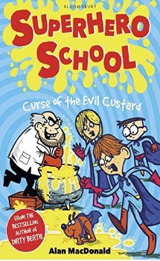  Superhero School Curse of the Evil Custard  Alan Macdonald | 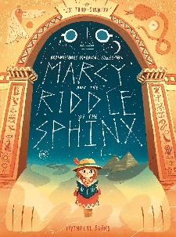  Marcy and the Riddle of the Sphinx  Joe Todd Stanton | 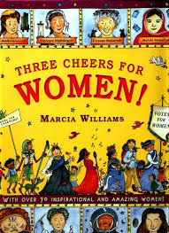  Three Cheers for Women  Marcia Williams | 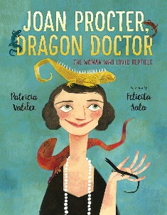  Joan Proctor Dragon Doctor  Patricia Valdez
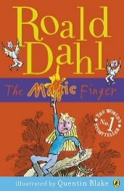  The Magic Finger  Roald Dahl | 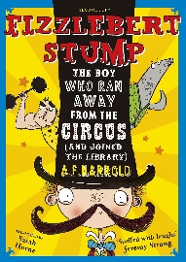  Fizzlebert Stump A.F. Harrold | 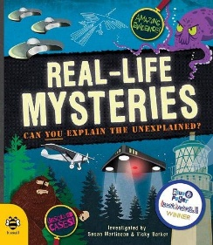  Real-life Mysteries  Susan Martineau & Vicky Barker | 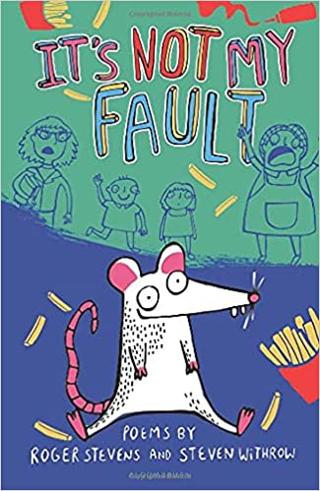  It’s not my fault  Roger Stevens and Steven Withrow | 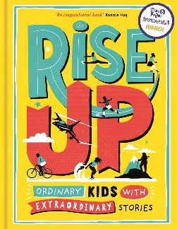  Rise Up  Amanda Li | 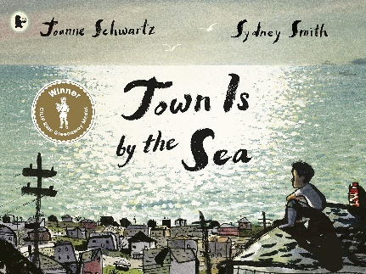  Town is by the Sea  Joanne Schwartz | 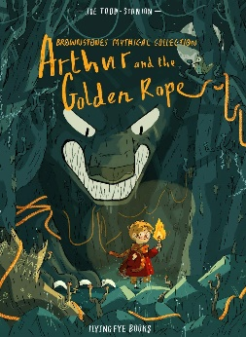  Arthur and the Golden Rope  Joe Todd Stanton | 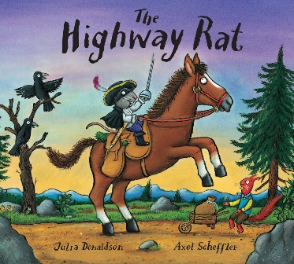  The Highway Rat  Julia Donaldson
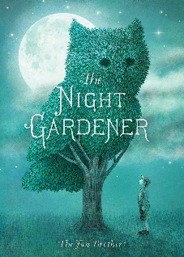  The Night Gardener  The Fan Brothers | 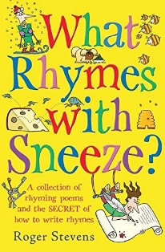  What Rhymes with Sneeze?  Roger Stevens | 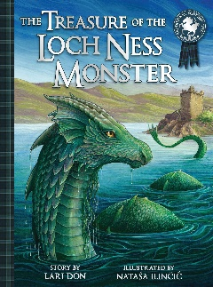  Treasure of the Loch Ness Monster  Lari Don | 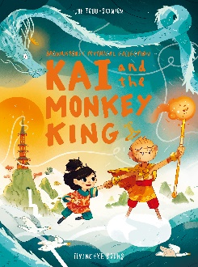  Kai and the Monkey King  Joe Todd Stanton | 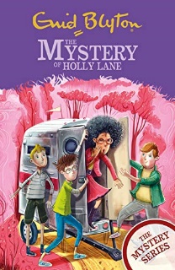  The Mystery of Holly Lane  Enid Blyton | 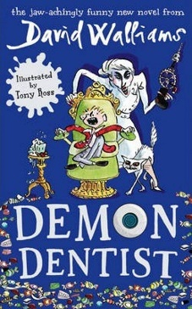  Demon Dentist  David Walliams | 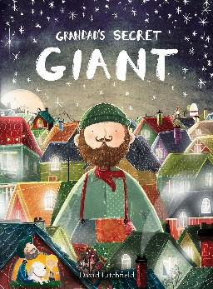  Grandad’s Secret Giant  David Litchfield | 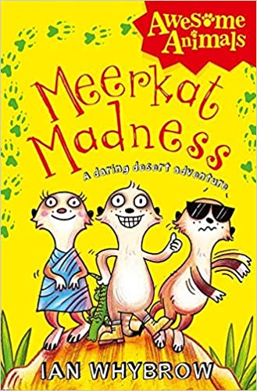  Merrkat Madness  Ian Whybrow

