Bingo Books is a collection of high-quality literature for you to share and explore with your child. These books should be enjoyed like a bedtime story, snuggled up with you reading - putting on your best voices and bringing the story to life. They are an opportunity for you to show your child the fun and adventure that comes with being a reader. Similar to the game ‘bingo’, the aim is to get a full house before leaving Year 1! Tick or cross them off as you go.  Children will have the opportunity to choose a new Bingo Book every Monday. |  |  |  | 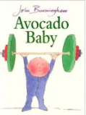  Avocado Baby – John Burningham
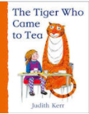  The Tiger Who Came to Tea – Judith Kerr | 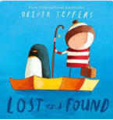  Lost and Found – Oliver Jeffers | 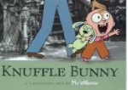  Knuffle Bunny – Mo Willems | 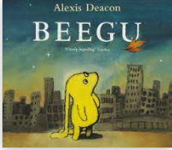  Beegu – Alexis Deacon | 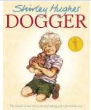  Dogger – Shirley Hughes
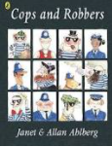  Cops and Robbers – A;lan and Janet Ahlberg | 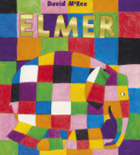  Elmer – David McKee | 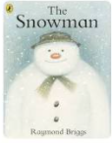  The Snowman - Raymond Briggs | 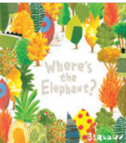  Where’s the Elephant? - Barroux Egmont | 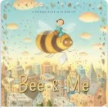  Bee & Me - Alison Jay
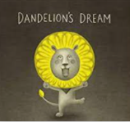  Dandelion’s Dream - Yoko  Tanaka | 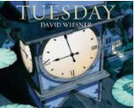  Tuesday - David Wiesner | 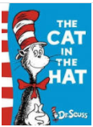  The cat in the hat – Dr Suss | 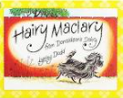  Hairy Maclary – Lynley Dodd | 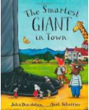  The smartest giant in town –  Julia Donaldson
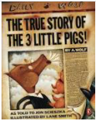  The true story of the three little pigs – J Scieszka | 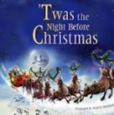  The night before Christmas – C C Moore | 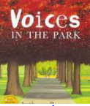  Voices in the park – Anthony Browne | 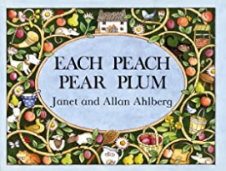  Each peach, pear, plum – Janet & Allan Ahlberg | 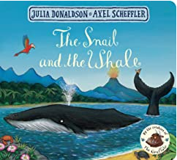  The Snail and the Whale - Julia Donaldson
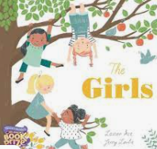  The Girls – Lauren Ace | 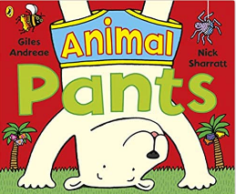  Animal Pants – Giles Andreae | 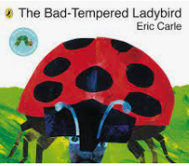  The Bad-tempered Ladybird - Eric Carle | 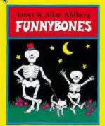  Funnybones - Allan Ahlberg | 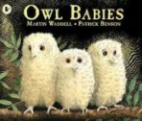  Owl Babies - Martin Waddell
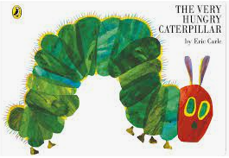  The Very Hungry Caterpillar - Eric Carle | 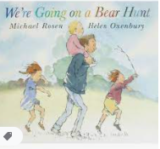  We’re Going on a Bear Hunt - Michael Rosen | 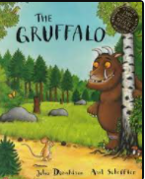  The Gruffalo - Julia Donaldson | 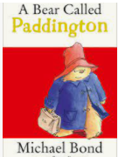  A Bear Called Paddington - Michael Bond | 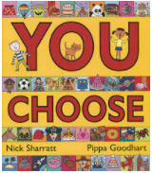  You Choose! - Pippa Goodhart
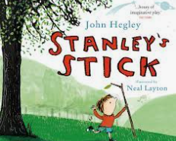  Stanley’s Stick - Neal Layton and John Hegley | 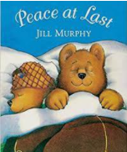  Peace at Last – Jill Murphy | 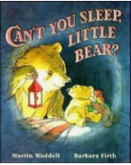  Can’t You Sleep Little Bear? – Martin Waddell | 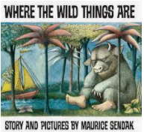  Where the Wild Things Are – Maurice Sendak | 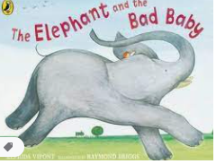  The Elephant and the Bad Baby – E Vipont & R Briggs

