Bingo Books is a collection of high-quality literature for you to share and explore with your child. Similar to the game ‘bingo’, the aim is to get a full house before leaving Year 5! Children will choose a new Bingo Book whenever they finish as some texts are longer than others. We do ask that you treasure these books as they are on loan from our Education Library Service. Please enjoy them and return in a good condition. If books are not returned (or are returned in a poor condition), I’m afraid we will have to ask for a contribution toward a replacement. Enjoy immersing yourself in some wonderful texts. I wonder which will be your favourite!
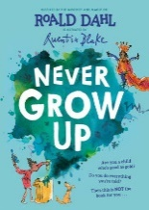  Never grow up (Roald Dahl and Quintin Blake) | 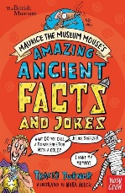  Amazing ancient facts and jokes | 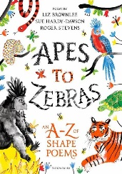  Apes to zebras The a-z of shape poems | 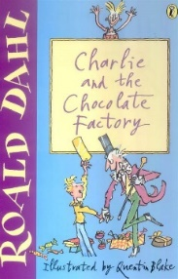  Charlie and the chocolate factory (Roald Dahl) | 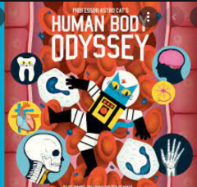  Human body odyssey
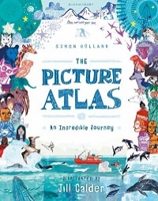  The picture atlas an incredible journey (Simon Holland) | 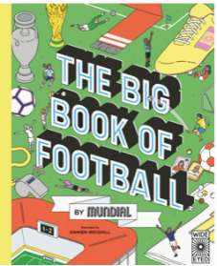  The big book of football (Mundial) | 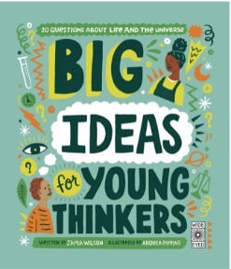  Big ideas for young thinkers | 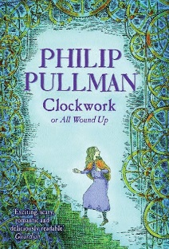  Clockwork (Phillip Pullman) | 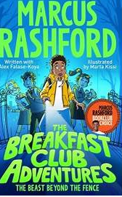  Breakfast Club Adventures  ( Marcus Rashford)
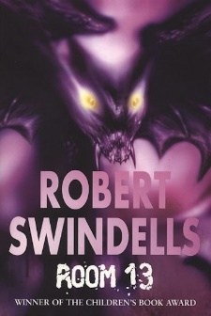  Room 13 robert swindells | 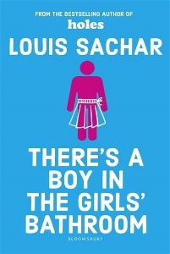  There’s a boy in the girl’s bathroom  (Louis Sachar) | 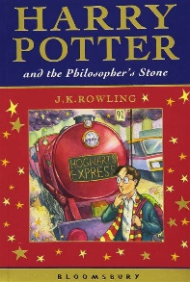  Harry potter and the philosopher’s stone  (J K Rowling) | 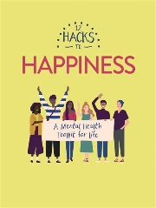  12 hacks to happiness | 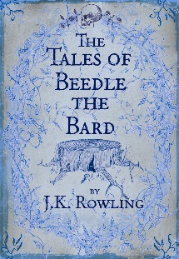  The tales of Beedle the Bard  (J K Rowling)
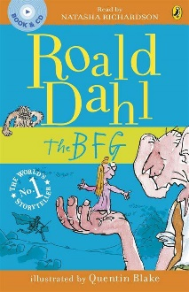  The BFG  Roald Dahl | 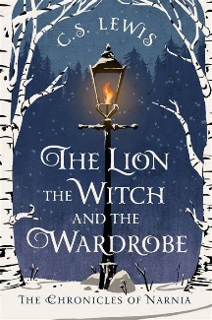  The lion, the witch and the wardrobe  ( C S Lewis) | 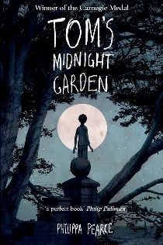  Tom’s midnight garden (Pillipa Pearce) | 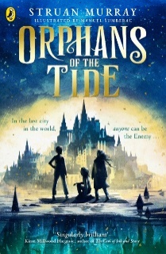  Orphans of the tide  (Shuan Murray) | 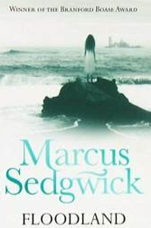  Floodland (Marcus Sedgewick)
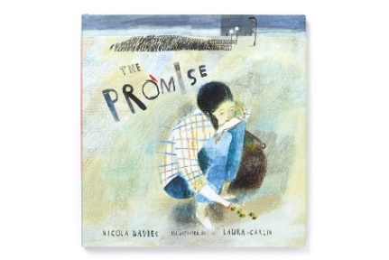  The promise  (Nicola Davies) | 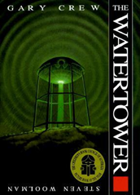  The Watertower  (Gary Crew) | 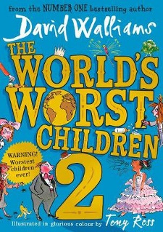  The world’s worst children  (David walliams) | 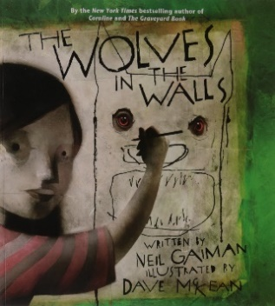  The wolves in the walls  (Neil Gaiman) | 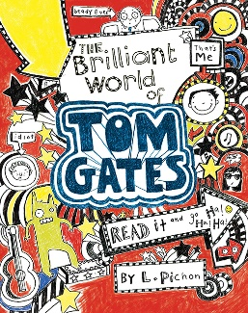  The brilliant world of Tom Gates
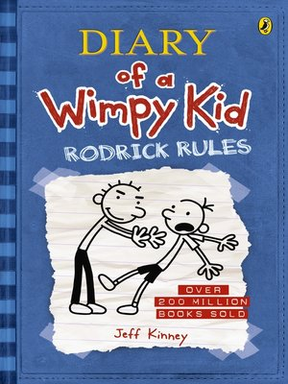  Dairy of a wimpy kid  Jeff Kinney | 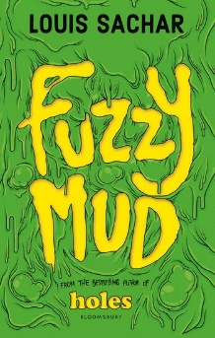  Fuzzy mud  louis Sachar | 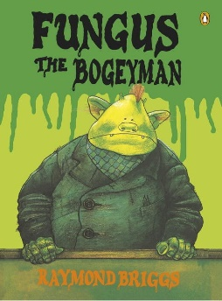  Fungus the bogeyman (Raymond Briggs) | 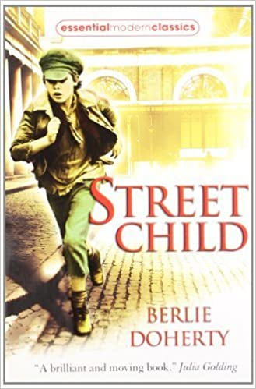  Street child  Berlie Doherty | 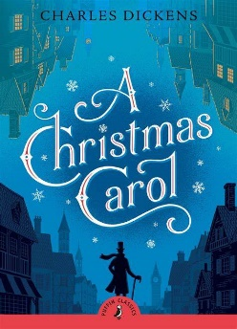  A Christmas Carol  (Charles Dickens)

