Vine Tree Primary School
English overview Year 2 2022-2023
Term  curriculum driver | 2 weeks Fiction | 2 weeks non-fiction | 1-2 weeks poetry | 1 -2 week  No Outsiders
Autumn 1  Curriculum driver:  Geography: what are seasons?  Science: materials monster | Title: One World  Author: Michael Foreman  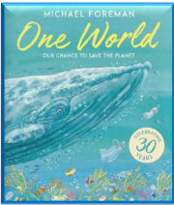  Title: Sector 7  Author: David Wiesner  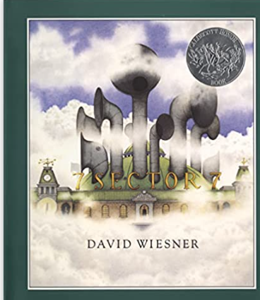  Title: Mrs Noah’s Pockets  Author: Jackie Morris  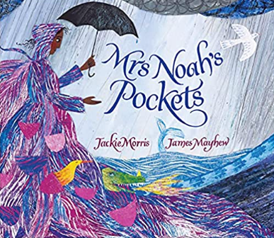  Title: Hello Rain!  Author: Kayo Maclear  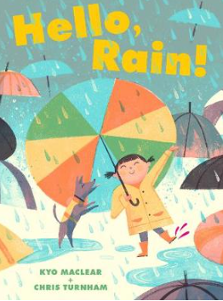  Title: Storm  Author: Sam Usher  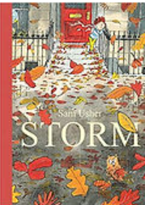  Title:  Content domain: 1e  predicting | Title: Tree: seasons come;seasons go  Author: Patricia Hegarty  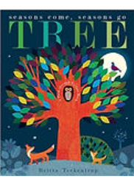  Title: Lift the flap: questions and answers about the weather  Author: Katie Daynes  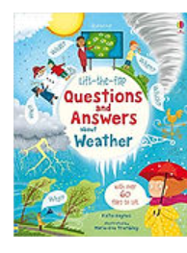  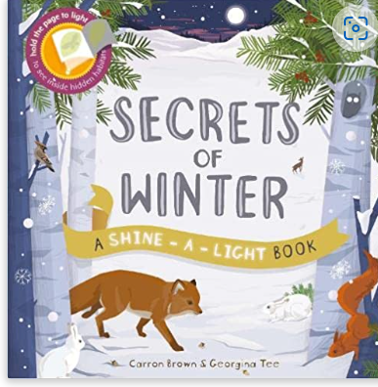  Or  Title: Materials Extreme facts  Author: Robin Twiddy  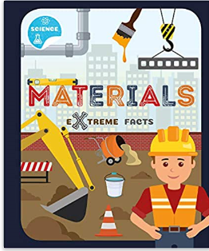  Title: Let’s build a house  Author: Mick Manning  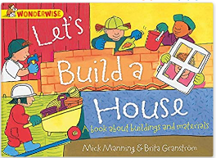  Content domain: 1b retrieving | Title: Poems about Seasons  Poet: Brian Moses  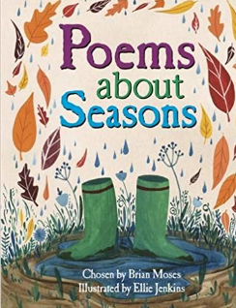  Title: seasons  Poet: Valerie Bloom (hot like fire and other poems p2)  Title: cold from ‘Out and About’  Poet: Shirley Hughes  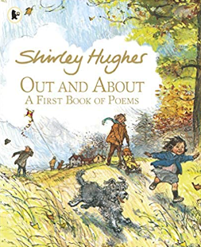  Title: A first book of the sea  Poet: Nicola Davies  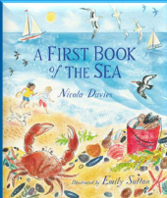  Title: a good play poet: robert Lous Stevenson  (from a poem for every night of the year p16)  Content domain: 1d inferring | Title: The Great big book of  families  Author: Mary Hoffman  Ros Asquith  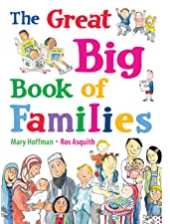  Theme: to understand  diversity  Content domain:  Visualisation
Autumn 2  Curriculum driver: history – great fire of London | Title: Vlad and the Great fire of London  Author: Katie Cunningham  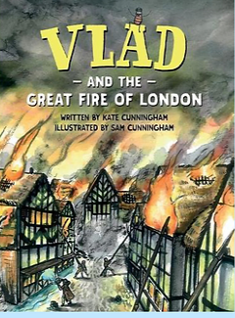  Content domain: 1d inferring | Title: the great fire of london  Author: Emma Adams  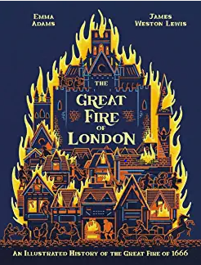  Title: Samuel Pepys Diary  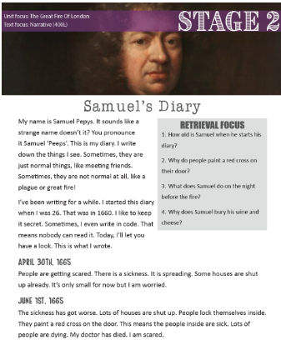  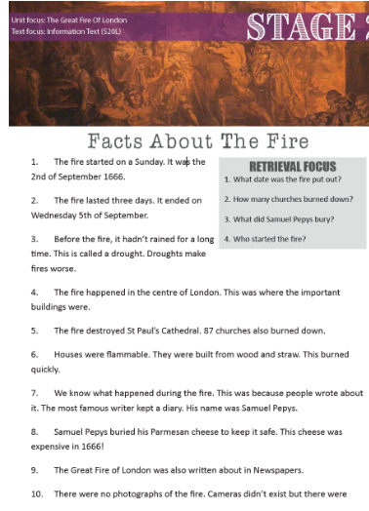  Content domain: 1a vocabulary  Content domain: 1b retrieval | Title: Fire fire fire!  Poet: Jane Goulbourne  Title:the great fire of London  Poet: Paul Perro  The Great Fire of London - a fun poem for kids (history-for-kids.com)  Title: the hungry fire (Literacy Shed +)  Title: The great fire of London | Centre for Literacy in Primary Education (clpe.org.uk)  Poet: Geroge Szirtes  Title: winter trees  Poet: George Szirtes  Winter trees | Centre for Literacy in Primary Education (clpe.org.uk)  Content domain: 1c summarising | No book for no  outsiders -author  focus  (Oliver Jeffers)
Spring 1  Curriculum driver: science – where does our food come from?  Author focus: Dick King Smith | Title: the Sheep Pig  Author: Dick King Smith  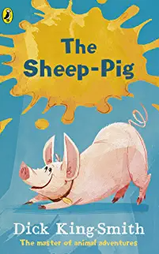  Title: The Hodgeheg  Author: Dick King Smith  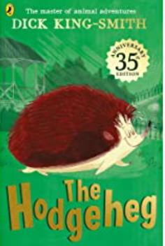  Books with letters:  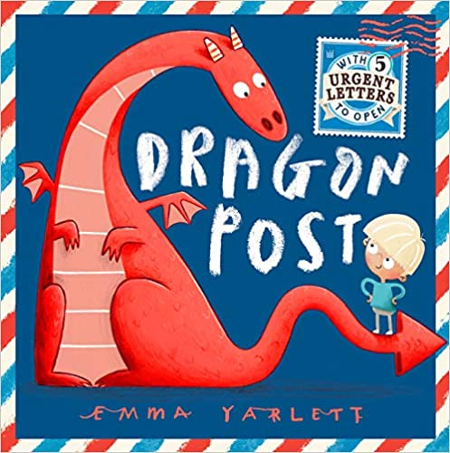  Content domain: 1c summarising  1a vocabulary | Title: A year on Adam’s Farm  Author:Adam Henson  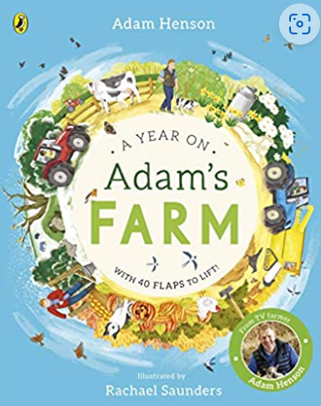  Title: the farm that feeds us  Author:  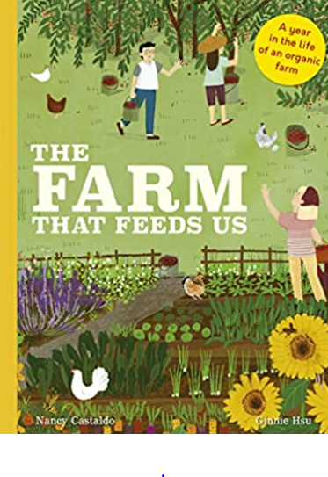  Title: How did that get in my lunchbox?  Author: Chris Butterworth  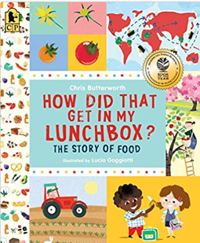  Title: The secret world of farm animals  Author: Jeffrey Masson  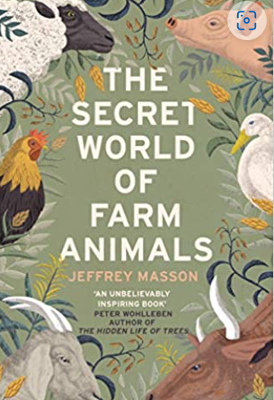  Title: Why are tomatoes a fruit?  Author: Children’s museum  https://www.childrensmuseum.org/blog/why-are-tomatoes-fruit  Title: Good enough to eat: a kid’s guide to nutrition  Author: Lizzy Rockwell  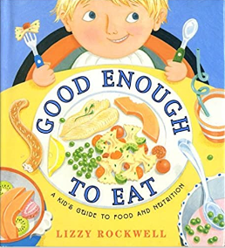  Content domain: 1b retrieval | instructions for growing Poetry (Tony Mitton)  Content domain: 1d inference  1c summarising | Title: The First  Slodge  Author: Jeanne  Willis  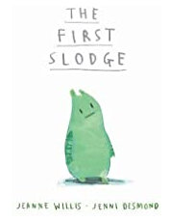  Theme: To understand  how we share the world  content domain: visualisation
Spring 2  Curriculum driver:  science  Our local environment: habitats and food chains | Title: The Rainbow Bear  Author: Michael Morpurgo  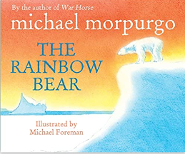  Title: Leaf  Author: Sandra Dieckmann  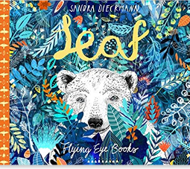  Content domain: 1d inferring  Content domain: 1b retrieval | title: Humaninal  Author: Christopher Lloyd  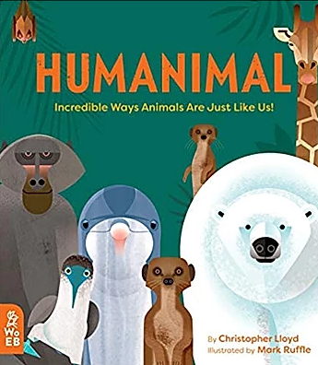  Title: Our Amazing World: Bears  Author: Kay de Silva  Title: the clue is in the poo  Author: Andy Seed  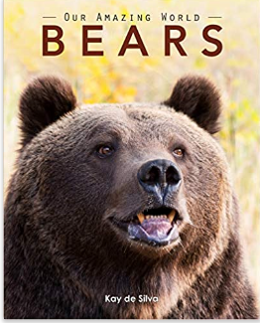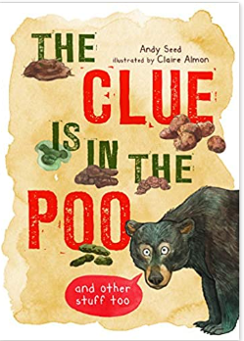  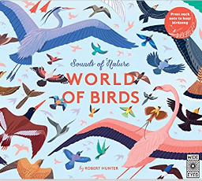  Or mini beast themed books:  Title: a beetle is shy  Author:Diana Hutts Aston  Title: A big book of bugs  Author:Yuval Zommer  Title: bonkers about beetles  Author: Owen Davey  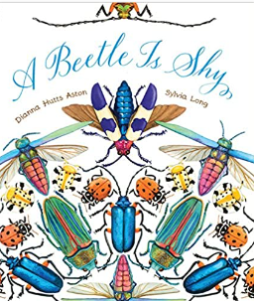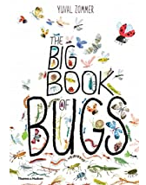  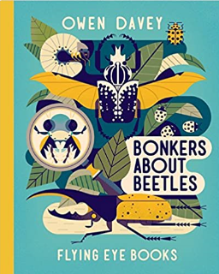  Title: the great fire of london  Author: Emma Adams  Content domain: 1a vocabulary | Title: Beware!  From Zim Zam Zoom anthology  Poet: James Carter  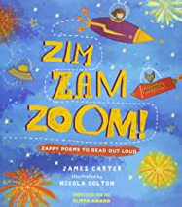  Title: A bear in his underwear  Poet: Brian Moses  Title: Mr Bear  Poet: Steven Camden  Poet: Title: Little lemur Laughing  Poet: Joshua Seiga;  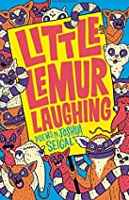  Content domain: 1c summarising
Summer 1  Curriculum  Driver: Science - Young Gardeners  Fiction focus: twisted tales | 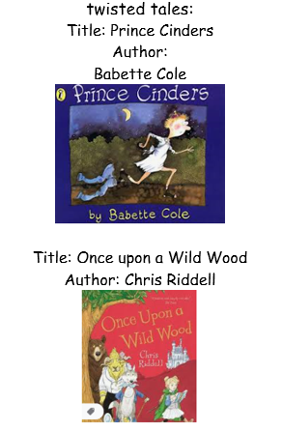  Title: the giant book of gaints  Author: Saviour Pirotta  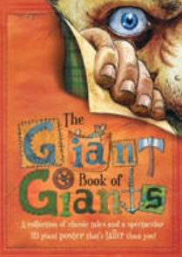  Poetry: revolting rhymes  Author: Roald Dahl  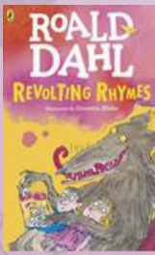 | Title: The Seedling that didn’t grow  Author:Britta Trecktrupp  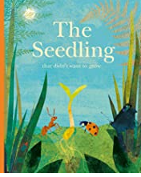  Title: it starts with a seed  Poet: Laura Knowles  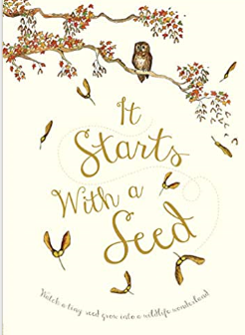  Title: what do you see when you look inside a tree?  Author:Emma Carlisle  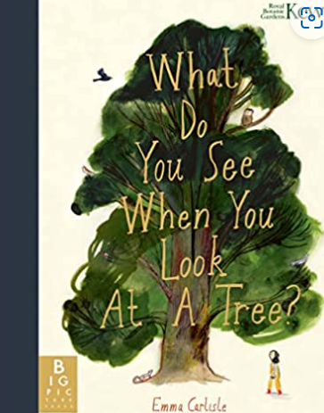  Title: what did the tree see?  Author: Charlotte Guillain  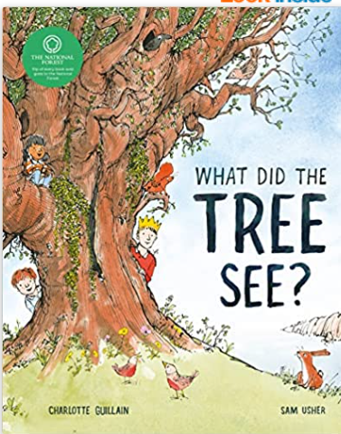  Title: tiny seed  Author: Eric Carle  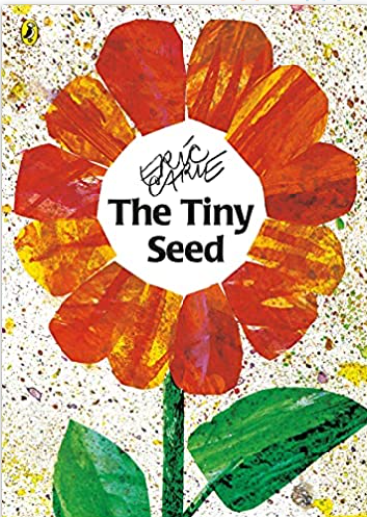  Title: the wild garden  Author: felicity Brooks  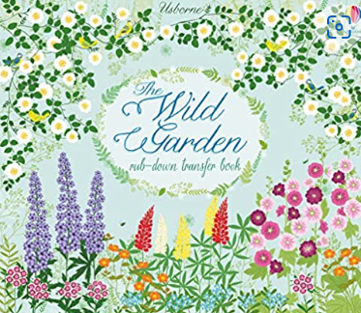  Content domain: | Title:  The Sleepy Giant (Charles E Carryl)  when a giant has a haircut (Ken Nesbitt)  The Giant's Accident (Charles Thompson)  Jack and the Beanstalk (Laura Salas)  Title: hey let’s go  Poet: James Carter from Zim Zam Zoom anthology  And  Title: grump, grump from Zim Zam Zoom  Title: nursery rhyme adverts  Poet: Rachel Rooney (my life as a goldfish and other poems p66,67,68) | Title: Blown Away  Author: Rob Biddulph  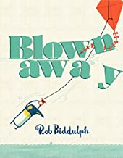  Theme: To be able  To work with  everyone in  my class
Summer 2  Curriculum driver: history – significant events  Geography: continents and oceans  Author focus: Matt  De la Pena | Title: Last stop on market street  Author: Matt de la Pensa  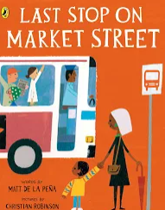  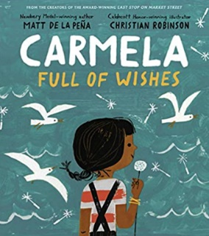  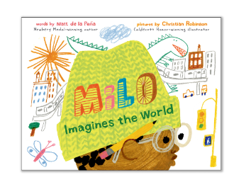  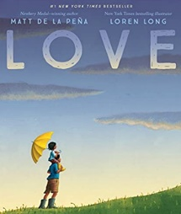  Content domain: 1d inference | Title: Meet the Oceans  Author: Caryl Hart  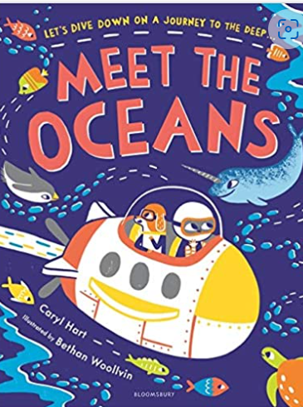  Title: Children’s activity Atlas  Author: Jenny Slater  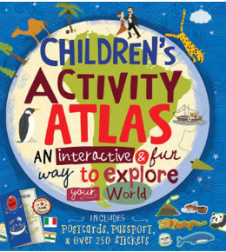  Title: Totally true adventures: the Titanic sinks  Author: Thomas Konklin  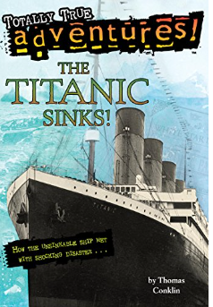  Title: Titanic  Author: National Geographic  Title: What was the Titanic?  Author: Stephanie Sabel  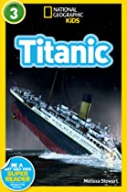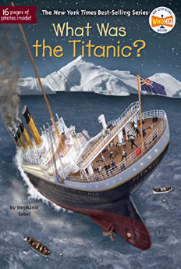  Content domain: 1b retrieval | Title: the book  Poet: Michael Rosen  Title: Lost  Poet: Michael Rosen  Available on CLPE website  Title: My Hand (Shape poem)  Poet: Joshua Seigal (little Lemur Laughing p24)  Content domain: Visualisation | Title: Just Because  Author: Rebecca Elliot  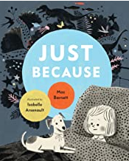  Theme: To feel proud of \m877777  being different  content domain: 1c  summarising

