Vine Tree Primary School
English Overview Reception 2022-2023
Term  link | Fiction  Reading | fiction  Reading | poetry | Steps to write
Autumn 1  friendship and animals | Title: Mr Big  Author: Ed Vere  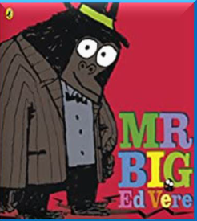  Poems Aloud: Cat’s Sleep anywhere by Eleanor Farjeon  Title: Dogger  Author: Shirley Hughes  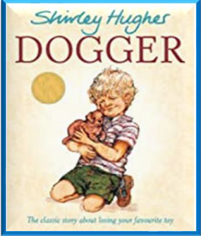  Poems Aloud: Dogs by Marchette Chute | Title: the tiger who came to tea  Author: Judith Kerr  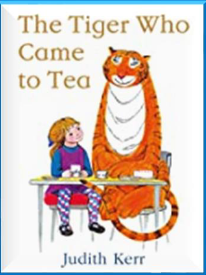  Title:Lost and found  Author: Oliver Jeffers  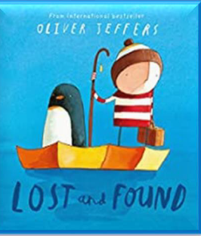 | Title: The Owl and the Pussycat  Poet: Edward Lear  Poems Aloud :  Tiger  Honey bear  I’m a little penguin  Whisky frisky  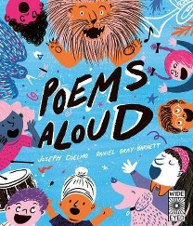  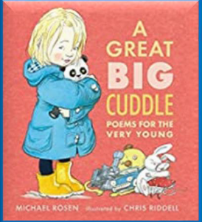 | Title: The Something  Author: Rebecca Cobb  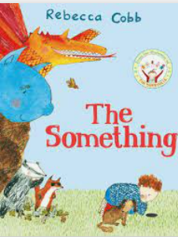
Autumn 2  Is there anybody out there? | Title: how to catch a star  Author: Oliver Jeffers  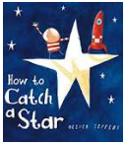  Title: the lost stars  Author: Hannah Cummings  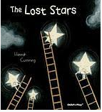 | Title: Beegu  Author: Alexis Deacon  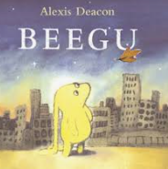  Title: Tiny little rocket  Author: David Fickling  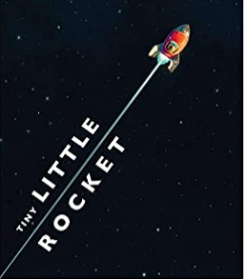  Poems Aloud : Five Little Astronauts | Title: I’m a little alien  poet: James Carter  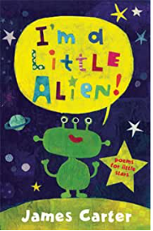  Title: A rocketful of space poems  Poet: John Foster  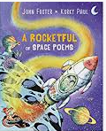 | Title: Star in a Jar  Author: Sam Hay  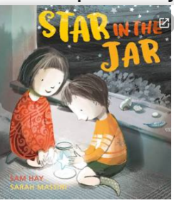
Spring 1  Curriculum driver: what makes a superhero? | Title:superbat  Author:Matt Carr  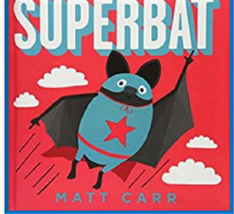  Title: newspaper boy and origami girl  Author: Michael Foreman  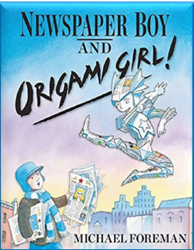 | Title: my mum is a superhero  Author: Angela Mcallister  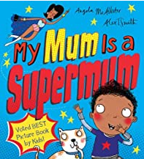  Title: george saves the world by luncthime  Author: Dr Jo Readman  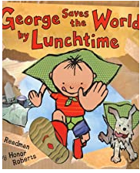 | Title: here come the superheroes  Poet: Nell Zetter  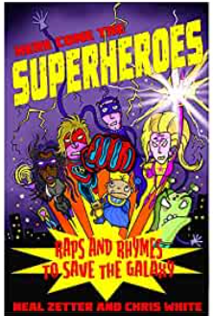 | Title: Supertato  Author: Sue Hendra  Literacy shed plus planning  Available  Hook: making potato superheroes  Designing and making capes  Writing to inform: wanted posters  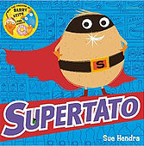
Spring 2  Curriculum driver:  Traditional tales | Title: pigs might fly  Author: Jonathon Emmett  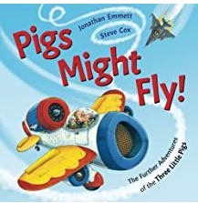 |  | Title: each peach pear plum  Poet: Allan Allberg  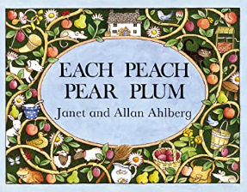 | Title: Jack and the  jellybean stalk  Author: Racheal Mortimer  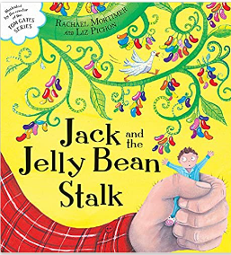  Jane Considine planning  Available  Hook: sweet trail, golden  Egg+ and giant  Beanstalk  Writing to instruct
Summer 1  Curriculum driver: growing | Title: Oliver’s Vegetables  Author: Vivian French  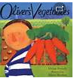  Title: I do not eat the colour green  Author: Lynne Rickards  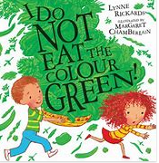 | Title: There’s broccoli in my ice cream  Author: Emily Mackenzie  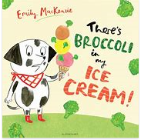  Title: the extraordinary gardener  Author: sam boughton  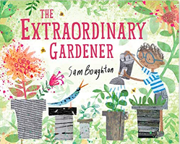 | Title:  From | Title: Handa’s Surprise  Author: Eileen Browne  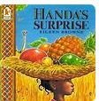  Jane Considine Planning  available
Summer 2  Curriculum driver: What lies beneath the sea? | Title: the rainbow fish  Author: Marcus Pfister  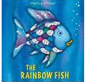  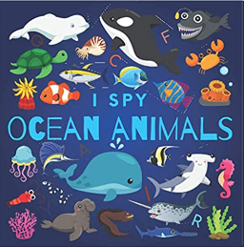  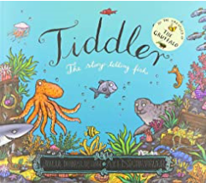 | Title: I wanna Iguana  Author: Karen Kaufman Orloff  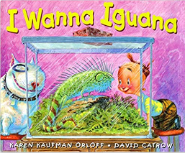  Jane Considine planning available  Hook: visit Pet Shop or invite them in  Writing a letter persuading parents to let them have a pet | Title: Walking with  my iguana  poet: Brian Moses  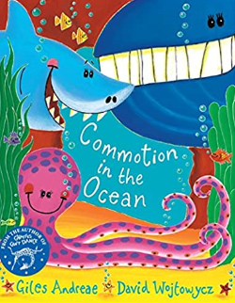 | Title: if sharks disappeared  Author: Lily Williams  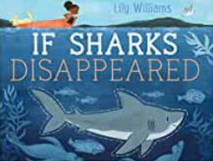  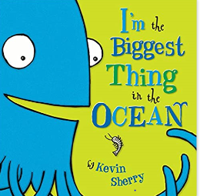  Hook: sea life Centre visit  Jane Considine planning  Available  Writing to inform: Non-fiction sentences about  Protecting the planet sharks/fish

