Vine Tree Primary School
English overview Year 2 2022-2023
Term and curriculum link | Title/author | Writing outcome (s)
Autumn 1  Curriculum driver: geography -what are seasons? | Title: The Secret of Black Rock  Author: Joe Todd Stanton  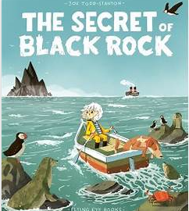  Title: The Big book of blue  Author: Yuval Zommer  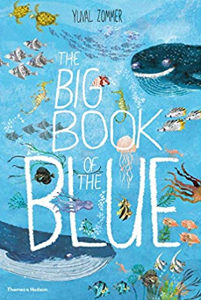  Poem: Ocean Travel  Poet: Jennifer Tweedie  Poem: Sea Shanty  Poet: Nicola Davies  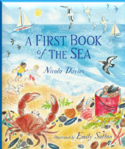 | Non-fiction: instructions for building a boat  Non-fiction: writing to inform  Non: fiction book (sentences)  Poem to perform
Autumn 2 | Title: The Great Fire of London  Author: Emma Adams  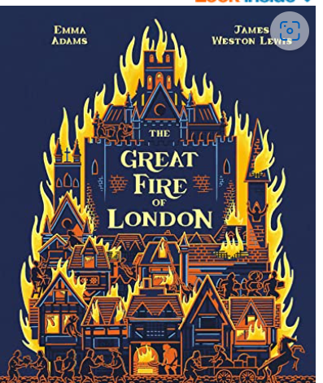  Literacy Shed + video: Pudding lane  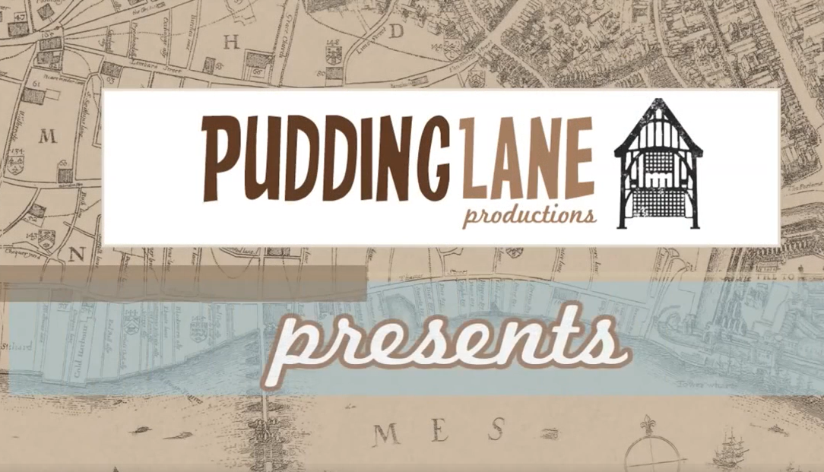 | Non-fiction – writing to inform  Fiction: setting description  Poetry: 3D flame poems
Spring 1  Curriculum driver: PSHE – How do we recognise our feelings? | Title: The day the crayons quit  Author: Drew Daywalt and Oliver Jeffers  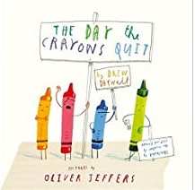  Title: It’s a great, big, colourful world  Author: Tom Shamp  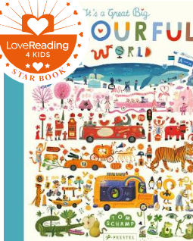  Title: crayon poem  Poet: James Carter (from a world full of poems p138)  Title: colour poems from life as a goldfish and other poems p24/25  Title: when I’m angry by Brenda Williams (from a world full of poems p42)  Title: a happy kenning by Claire Bevan (from a world full of poems p52)  Title: my colours  Poet: Colin West (from a world full of poems p136) | Non- Fiction: writing to recount: letters  Poetry: colours and emotions
Spring 2  Curriculum driver: science – habitats and food chains | Title: The bear and the piano  Author: David Litchfield  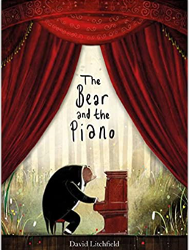  Title: A book of bears  Author:  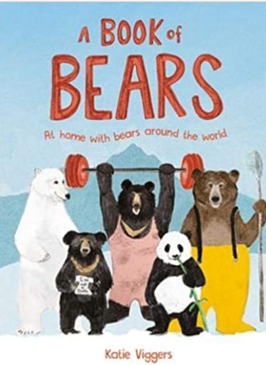 | Fiction: story opening  Non-fiction: writing to inform: a guide to bears
Summer 1 | Title: Jack and the baked beanstalk  Author: Colin Stimpson  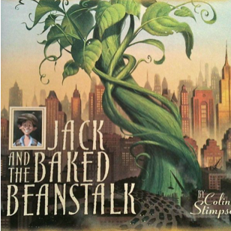  Or  Title: the true story of the 3 little pigs  Author: Jon Scieszka  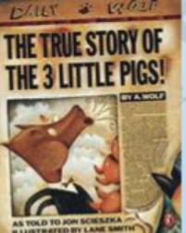  Title: inside the villains  Author: Clotilde Perrin  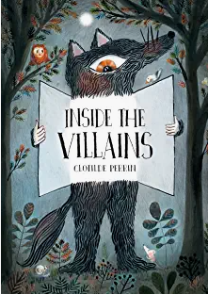 | Fiction: twisted narrative  Giant character description
Summer 2  Curriculum driver: history – local history | Title: If you were a kid aboard the Titanic  Author: Josh Gregory  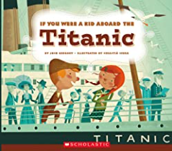  (selected extracts)  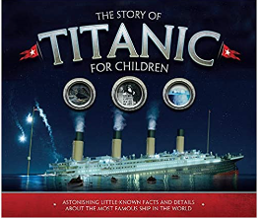 | Non-fiction: diary entry  or recount of class experience  Non-fiction: Welcome aboard the Titanic (persuasive brochure)

