Vine Tree Primary School
English overview Year 5
Term | Title/author and curriculum link | Writing outcome
Autumn 1  Geography driver: Can I become a cartographer? | Title: The Girl of Ink & Stars  Author: Kiran Millwood Hargrave  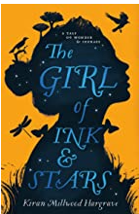  Title: Falling out of the Sky  Poet: Emma Wright  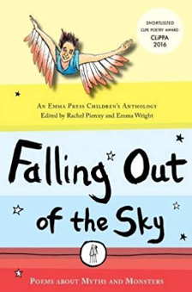  Title: An emotional Menagerie  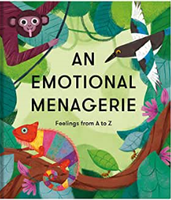 | Non-fiction: Persuasive writing – Why is my mythical beast the most beastly of all?  Fiction: mythical creature decryptions  mythical monster kenning  abstract poem – based on Liar  poem  poetry performance – The Minotaur (falling out of the sky)
Autumn 2  Geography driver: I’m a year 5 pupil, can you get me out of here? | Title: Francis Produced by: Dave Eggars  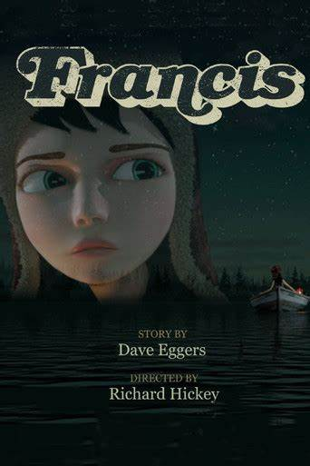  Title: Winter’s Tales Author: Lari Don  Title: Wld Wolf Author: Fiona French  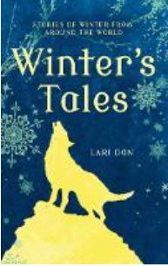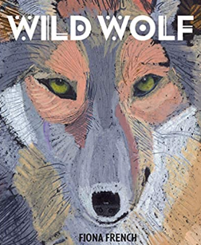 | Fiction - Setting + tension description  Fiction: folk tales from North America/South America  Non-fiction – argument: Does anyone have the right to take away a person’s freedom?
Spring 1  MFL driver: Warsy France residential | Title: Rooftoppers  Author: Katherine Rundell  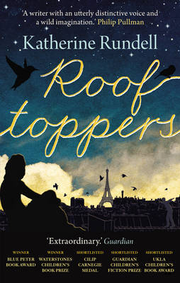 | Fiction: Chapter writing: description, action and dialogue.  Non-fiction: persuasive writing: visit Paris
Spring 2  History and D&T driver:  Can the clocks be turned back? | Title: The invention of Hugo Cabret  Author: Brian Selznick  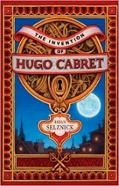 | Non-fictional: instructional writing  Fiction: short story
Summer 1  Science driver:  Is there anybody out there? | Title: Cosmic  Author:Frank Cottrell-Boyce  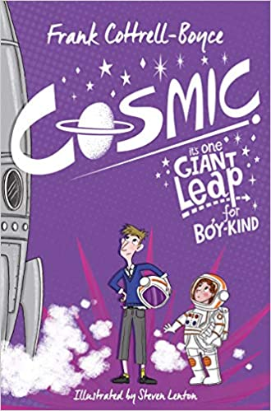  Title: Curiosity  Author: Markus Motum  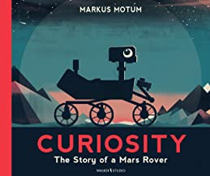 | Non fiction – biography/  recount  or newspaper report  Non-fiction -explanation text (create Mars Rover and How to work it)
Summer 2  Geography driver: rainforest biomes | Title: The Lost Book of Adventure  Author: Unknown Adventurer  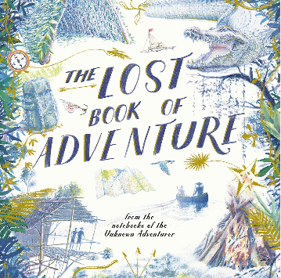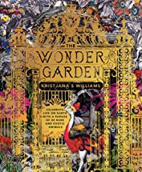  Title: An anthology of intriguing Animals  Author: Ben Hoare  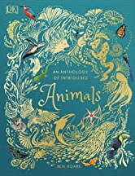 | Non-fiction -survival guide writing  Non-fiction  Creating a rainforest species/biome  Fiction: Writing from a different viewpoint

