Vine Tree Primary School
English overview Year 1 2022-2023
Term and curriculum link | Title/author | Writing outcome (s)
Autumn 1  Curriculum driver: geography where in the world do people live? | Title: The Storm Whale by Benji Davis  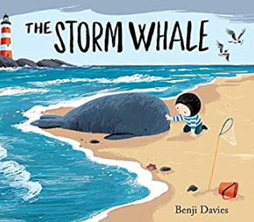  Oh Dear by Micheal Rosen  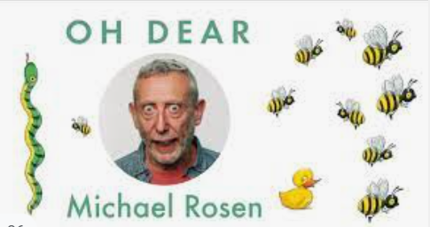 | Non –fiction: Lists/labelling (outfits, Noi’s house, Noi’s picnic)  Non-fiction: Thank you notes  Talk for writing: perform a poem
Autumn 2  Curriculum driver: history: Who am I? | Title: Paddington  Author: Michael Bond  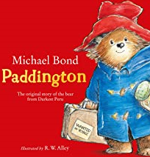  Title: Paddington Pop up London  Author: Chris Van Allsburg  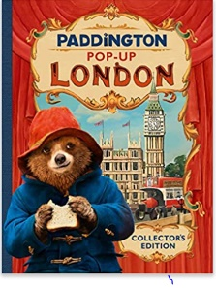  Title: All aboard the London Bus  Poet: Patricia Toht  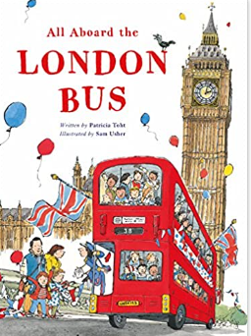 | Fiction: talk for writing  Non-fiction: Come to London /instructions for Paddington  performance poetry
Spring 1  Curriculum driver: D&T moving story books | Extended rhymes:  Title: Oi Frog! Oi Dog!  Author: Kes Gray  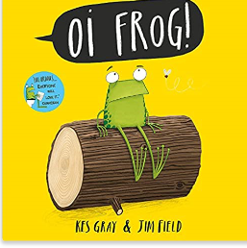  Title: The Bog Baby  Author: Jeanne Willis  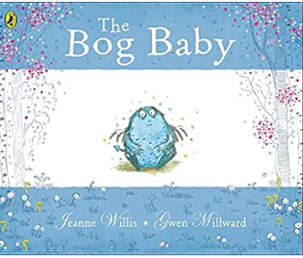 | Rhyming sentences  Fiction Talk for writing: story opening
Spring 2  Curriculum driver: Science:  Plants and animals | Title: The Tale of peter Rabbit  Author: Beatrix Potter  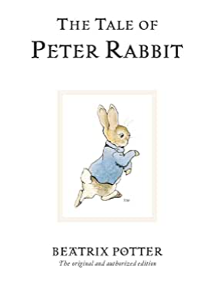  Poem: Rabbit Habit  Poet: Liana Mahoney  Or  Poem: In our Garden  Poet: Beatrix Potter | Non-fiction: instructional writing  Performance poetry
Summer 1  Curriculum driver: D&T Puppets  Curriculum driver: Science:  What is it like in Polar places? | Title: Inside the Villains  Author: Clotilde Perrin  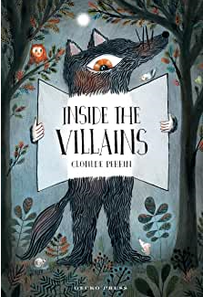  Title: Wolves  Author: Emily Gravett  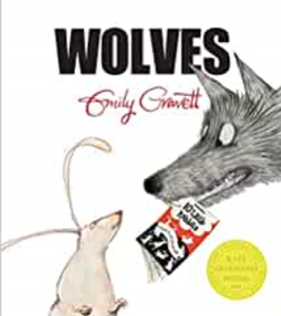 | Fiction: ‘villain’ stories  Non-fiction: information booklet about the arctic wolf or letter writing
Summer 2  Curriculum driver: Science:  Where can we go on holiday? | Title: Flotsam  Author: David Wiesner  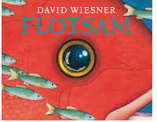  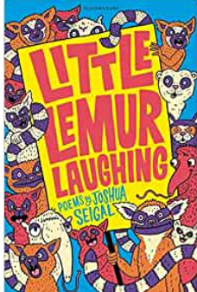 | Fiction: Short story: a discovery adventure linked to an ‘Underwater World’  Seaside Poetry  Seagulls (little lemur laughing anthology p17)  The Sea p18  Sand p19

