Vine Tree Primary School
English overview Year 4
Term | Title/author and curriculum link | Writing outcome (s)
Autumn 1  Curriculum driver: Geography  Where would you build a city? | Title: River Story  Author: Meredith Hooper  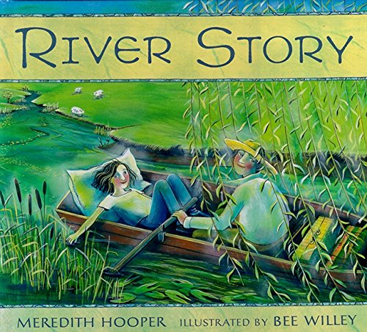  Title: The Rhythm of the Rain author: Graham Baker Smith  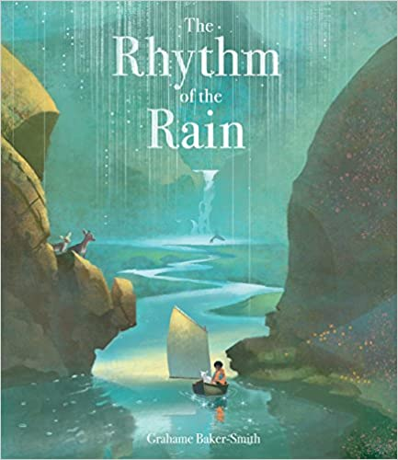  Poem: The Rain has silver sandals Poet: May Justus (p382 read me anthology)  Title: I asked the river  Poet: Valerie Bloom (hot like fire p84) | Fiction: Setting Description  Poetry – A river journey  Performance poem
Autumn 2  Curriculum driver:  Geography -North America | Title: The Man who walked between the Towers  Author: Mordicai-Gerstein  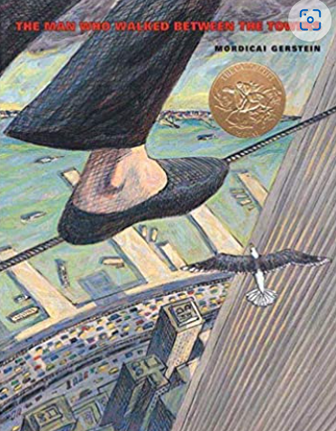 | Non-fiction: persuasive brochures – Come to New York!  Fiction: Character description/tension paragraph
Spring 1  Author focus: Chris Riddell  Curriciculum driver: D&T food | Title: Midnight Feast  Author: A F Harrold  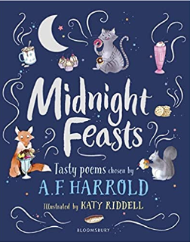  Model:  Title: praise poem for Yorkshire pudding  Poet: Ian McMillan  Title: Poetry Pie  Poet: Roger McGough  Class text  Title: guardians of the magic  Author: Chris Riddell  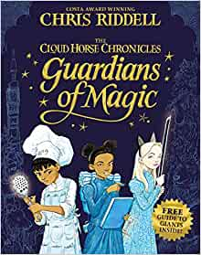 | Non-fiction: recipe writing  Fiction: chapter including dialogue and action  performance poem  poetry writing based on food
Spring 2  Curriculum link: science- living things/  classification | Title: Whales: an illustrated celebration  Author: Kelsey  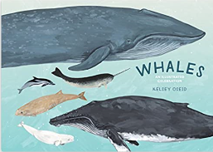  Title: The Whale  Author: Ethan & Vita Murrow  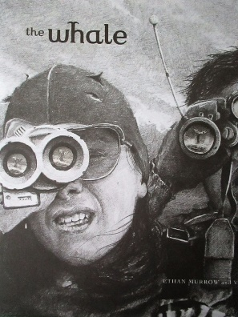 | Non-fiction: Non-chronological reports  Non-fiction: Newspaper report
Summer 1  Curriculum link:  History -  How can we rediscover the wonders of Ancient Egypt? | Title: Secrets of a Sun King  Author: Emma Carroll  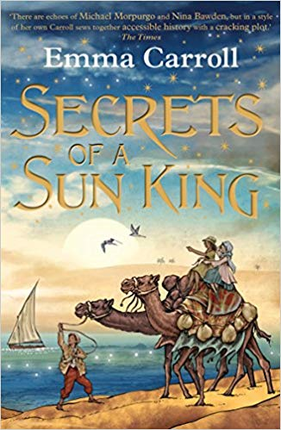  Title: Egyptology  Author: Emily Sands  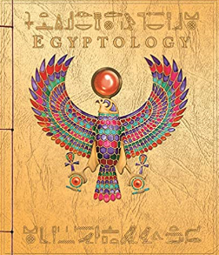 | Fiction: story opening  Non-fiction: informal letter/diary writing
Summer 2  Curriculum link:  PSHE/RSE – How can we manage risks in different places? | Title: The Boy at the back of the class  Author: Onjali Rauf  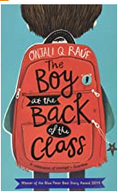  Title: The Journey  Author: Francesca Sanna  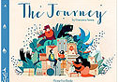 | Non-Fiction: persuasive writing  Narrative: quest story

