Vine Tree Primary School
Writing Overview Year 6
Term | Title/author and curriculum link | Writing outcome
Autumn 1  History/Geography driver: What part did Britain have to play in WW2? | Title: Rose Blanche  Author: Roberto Innocenti  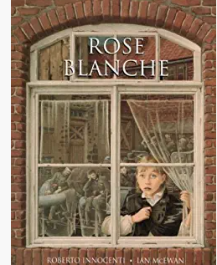
Autumn 2  Science driver: Have we always looked like this? | Title: Skellig  Author: David Almond  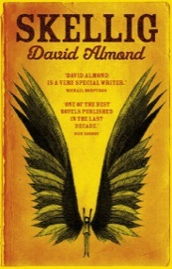 | Fiction – description, action, dialogue chapter (the discovery of Skellig/the fire/the flight)  Non-Fiction argument text – should children be home schooled?
Spring 1  Curriculum link: history – civil rights  R.E – justice and freedom | Title: Martin Luther King  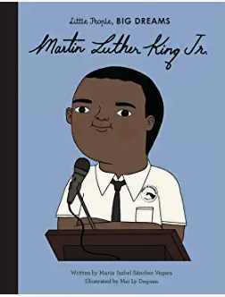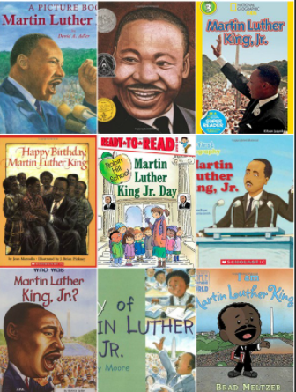  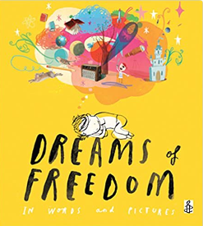 | Non-fiction: biography  Argument: is it right to take away someone’s freedom?
Spring 2  Curriculum link: How can you light up your life?  (Science: electricity and light) | Title: the nowhere emporium  Author: Ross Mackenzie  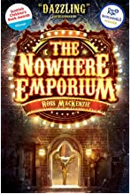 | Fiction: suspense narrative
Summer 1 | Title: The Fantastic Flying Books of Mr Morris Lessmore  Author: W E Joyce  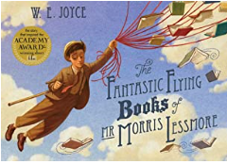  Poems:  - Uses (Rachel Rooney –wonderland Alice in poetry p7)  - The weaver of words (Sue Hardy-Dawson - where zebra’s go p8)  Title: Just words (Matt Goodfellow – bright bursts of colour p22) | Non-fiction: diary writing  fantasy short story narrative  poetry writing: the power of words/books
Summer 2  Curriculum link: science- the Titanic  PSHE – What will change as we become more independent? | Title: Survivors  Author: David Long  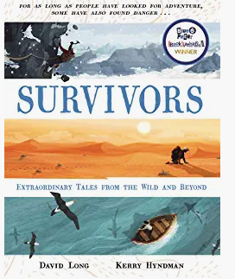  Poem: tomorrow has your name on it  Poet: Roger McGough | Poetry writing: a message to the future/Tomorrow has your name on it!

