Vine Tree Primary School
English overview Year 3 2022-2023
Term  Curriculum  Driver | Title/author and curriculum link | Writing outcome (s)
Autumn 1  Curriculum driver:  Science forces and magnets | Title: The Iron Man  Author: Ted Hughes  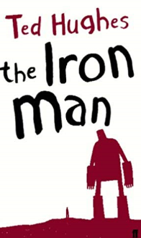  Poetry: My Robot  Gareth Lancaster   | Non-fiction: explanation text:  How to build a robot friend  Fiction: character description (talk for writing)  Linked to either video/The Iron Man  Performance poetry  Create own My robot poems
Autumn 2  Curriculum driver:  Science – lights and shadows  Author focus: Carol Ann Duffy | Title: Lost Happy Endings  Author: Carol Ann Duffy  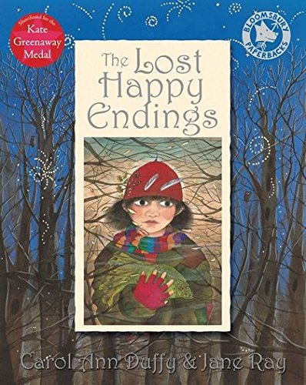  Title: Another Night before Christmas  Author: Carol Ann Duffy  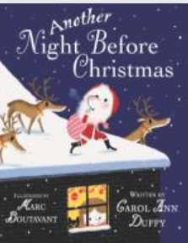  Poetry:  Title: 2 witches discuss good grooming  poet:  John Coldwell  Title: cross Words  Poet: Gina Douthwaite  Title: The Witch, the Prince and the Girl in the Tower  Poet: Sue Cowling  Title: 10 things found in a wizard’s pocket  Poet: Ian McMillan  Title: Ogre Boulder  Poet: Phil Bowen | Fiction: writing an opening (setting)  Poetry:  Use of vocabulary  Shape poems  poems to perform
Spring 1  Curriculum driver: history – Stone Age | Title: Stone age Boy  Author: Satoshi-Kitamura  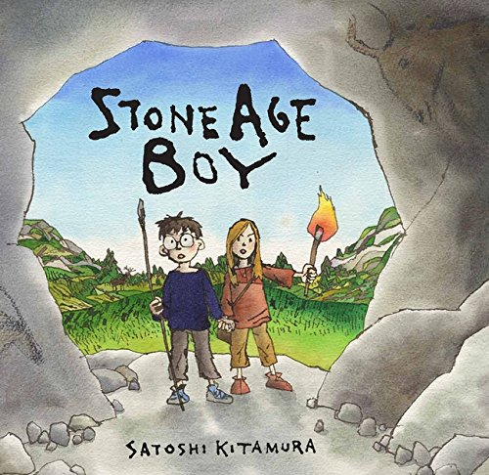  Title: How to Wash a Woolly Mammoth  Author: Michelle Robinson  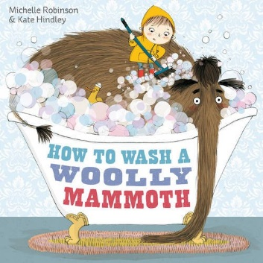  Title: woolly mammoth  Author: Mick Manning  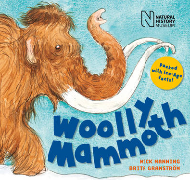 | Fiction: Writing a portal story (dialogue)  Non-fiction: letter writing or non-chronological reports on Woolly mammoths
Spring 2  Curriculum driver: science plants | Title: The Flower  Author:  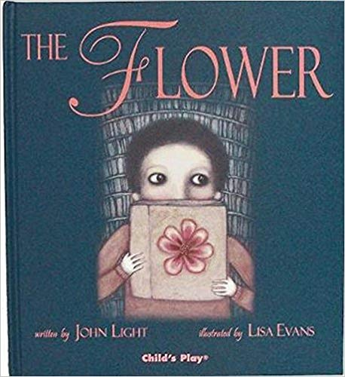  Title: The General  Author: Michael Foreman  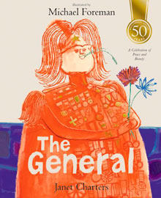  Or:  Title: The Gardener  Author: Sarah Stewart  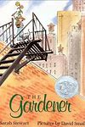 | Fiction: discovery story  writing a resolution/ending  (for The Flower and  The general)  Non-fiction: letter writing
Summer 1  Curriculum driver: history ancient Greeks | Title: The Crow’s Tale  Author: Naomi Howarth  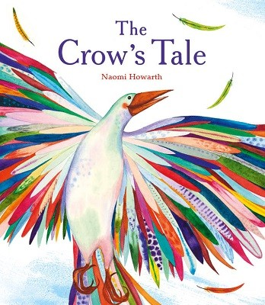  Title: Starbird  Author: Sharon King-Chai  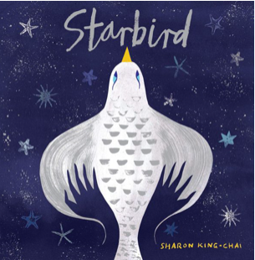 | Fiction: writing a fable
Summer 2  Curriculum driver: mirrors and windows (diversity) and music | Title: The Wisp  Author: Zana Fraillon and Grahame Baker Smith  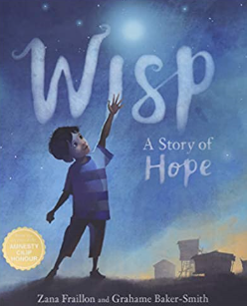 | non-fiction: diary entry

