School Improvement Curriculum Plan: Writing |  | Vine Tree Primary School |  | Date:5.9.2022
 |  | Curriculum Manager: Emily Woodward
Action Planning Document
Area of Development / Intent | Actions / Implementation |  | Success Criteria / Impact |  | Cost and Timescale
To ensure that the teaching of writing is consistently good in all year groups in order to raise standards in writing. | Teachers create medium term planning overview: why this lesson? Why now? Alongside English lead.  Learning environment walk September (SLT)  Literacy Counts environment walk (November)  Writer’s toolkits and year group spelling lists linking to text are created half termly by teachers  Literacy counts CPD ‘meeting the standard in year …’  EW/DL to attend LA training on: leading and teaching writing effectively/ deepening understanding of writing. |  | Children are provided with the skills they need to write confidently and accurately.  High quality models and challenging texts engage and inspire learners to write.  All adults are exemplary models for writing.  Children are immersed in a language rich environment.  % of children meeting the year group expectations in writing is in line with national.  All teachers are confident in the assessment of the writing standard in their year group.  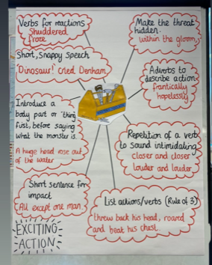 |  | Literacy Counts support package.
To provide a learning environment for writing that scaffolds and supports all learners | Learning environment walk September (SLT)  EW to provide model for English working wall to implement a consistent approach.  Literacy Counts environment walk (November)  Writer’s toolkits and year group spelling lists linking to text are created half termly by teachers  Curriculum vocabulary wall in all classroom.  Password of the day. |  | All classrooms have a diverse range of purposeful resources to support and scaffold writers.  English learning walls are consistent across school.  Adults and children regularly refer to and use the working wall to support writing.  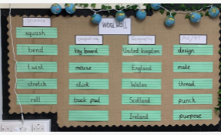  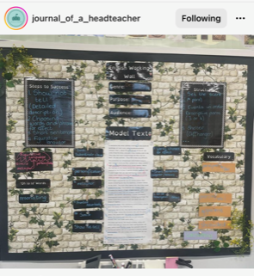  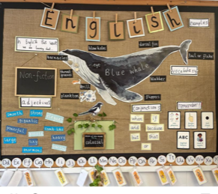 |  | Each half term  Part of LC support package.  Floating shelves (£16.99)  Acrylic Floating Shelves for Wall, 2 PCS Floating Bookshelf, No Drill Display Picture Shelves, Wall Storage Shelves Used for Bathroom/Kitchen/Living Room (Transparent) : Amazon.co.uk: Home & Kitchen  Sentence strips (£8.50)
To expose all learners to high quality models. | LC audit and lesson observations  1:1 Planning surgeries with LC  Literacy Counts professional development staff meetings x2  Password of the day. |  | All adults model high quality writing that inspire and motivate all learners.  High quality models are displayed and referred to during writing sessions.  Writer’s toolkits and learning walls support children’s independent writing. |  | £2800 literacy Counts support package.
To develop fluency and stamina for writing. | Daily hold a sentence/sentence accuracy in all classes  RAG rated overviews passed up to teachers and used for planning daily sentence accuracy.  Non-negotiables created for ‘sentence accuracy in year _’ and these are displayed on the learning wall and in books.  Planning for daily sentences ensures gaps in knowledge are addressed.  Daily handwriting in all classes (using penpals, writing repeater).  Weekly differentiated spelling lessons (using Rising Stars/Ed Shed) and home learning set weekly to consolidate.  Password of the day. |  | Children are given daily opportunities to write ambitious sentences.  Gaps in learning are identified, planned for and taught.  All teachers have high expectations of all learners.  Children are confident in assessing their own writing.  Children take pride in their handwriting.  Regular time is allocated to the explicit teaching of spelling and handwriting.  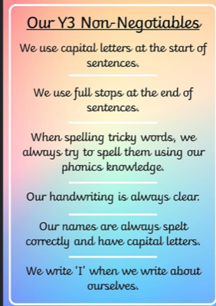 |  | Ed Shed subscription.  Rising stars subscription.  Penpals scheme.
To close the gap in spelling and handwriting | RAG rated overviews to be used to plan for gaps in learning for spelling and handwriting to establish baseline for all children.  Baseline assessments for spelling (year group lists)  Precision teaching training for all staff and to commence autumn 1 for SEN and vulnerable children  Bottom 20% spelling to be assessed half termly to ensure targeted intervention.  EW to trial sky, grass, ground for KS2 handwriting. |  | Children take pride in their handwriting.  Regular time is allocated to the explicit teaching of spelling and handwriting.  Learning walls provide scaffolding and support for learning as well as high quality WAGOLLs. |  | Precision teaching + £320  Rising stars subscription.  Ed Shed subscription.  Penpals scheme.  Literacy Counts support package.
To ensure that children with special educational needs make at least good progress in writing. | Senco to track progress of children on the SEN register.  Targeted, rigorous and regular intervention to be delivered for spelling and handwriting.  Impact of intervention to be monitored and reviewed at least half termly by SLT.  Quality first teaching of spelling, handwriting and transcription (whole class and interventions) to be monitored by slt through learning walks and book scans.  DW/DL to carry out half termly learning walks for interventions. |  | Children with special educational needs receive targeted and rigorous intervention and teaching which ensures they make good progress.  All adults deliver quality first teaching and have high expectations of all learners. |  | Precision teaching +  Ed Shed  Rising Stars  Penpals

